Maths Mastery - A Brief Overview
2014 Mathematics Curriculum
In 2014, significant changes were made to the maths curriculum. It was made more challenging when levels were abolished. At Crowle CE First School, we have moved away from flexible groups to whole class teaching. We asked ourselves, were we meeting the curriculum's aims and purpose?

The 2014 national curriculum for mathematics was designed to raise standards in maths, with the aim that the large majority of pupils will achieve mastery of the subject.
Mathematics programmes of study state that:
- All pupils should become fluent in the fundamentals of mathematics;
- The expectation is that the majority of pupils will move through the programmes of study at broadly the same pace.
- Pupils who grasp concepts rapidly should be challenged through rich and sophisticated problems before any acceleration through new content.
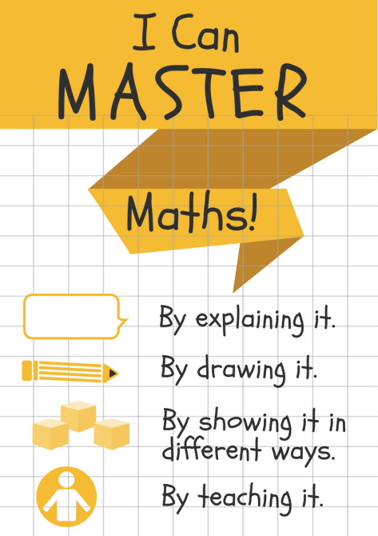
Teaching Primary Mathematics for Mastery
Mastering maths means acquiring a deep, long-term, secure and adaptable understanding of the subject. At any one point in a pupil’s journey through school, achieving mastery is taken to mean acquiring a solid enough understanding of the maths that’s been taught to enable him/her move on to more advanced material.

What does it mean to master something?
- I know how to do it;
- It becomes automatic and I don’t need to think about it -for example, driving a car;
- I’m really good at doing it –painting a room, or a picture;
- I can show someone else how to do it.
Mastery of Mathematics is more...
- Achievable for all;
- Deep and sustainable learning;
- The ability to build on something that has already been sufficiently mastered;
- The ability to reason about a concept and make connections;
- Conceptual and procedural fluency.

Teaching for Mastery - Our Mindset
- We believe that all pupils can achieve;
- The children believe that they can achieve.
- Keeping the class working together so that all can access and master mathematics;
- Development of deep mathematical understanding;
- Longer time on key topics, providing time to go deeper and embed learning.
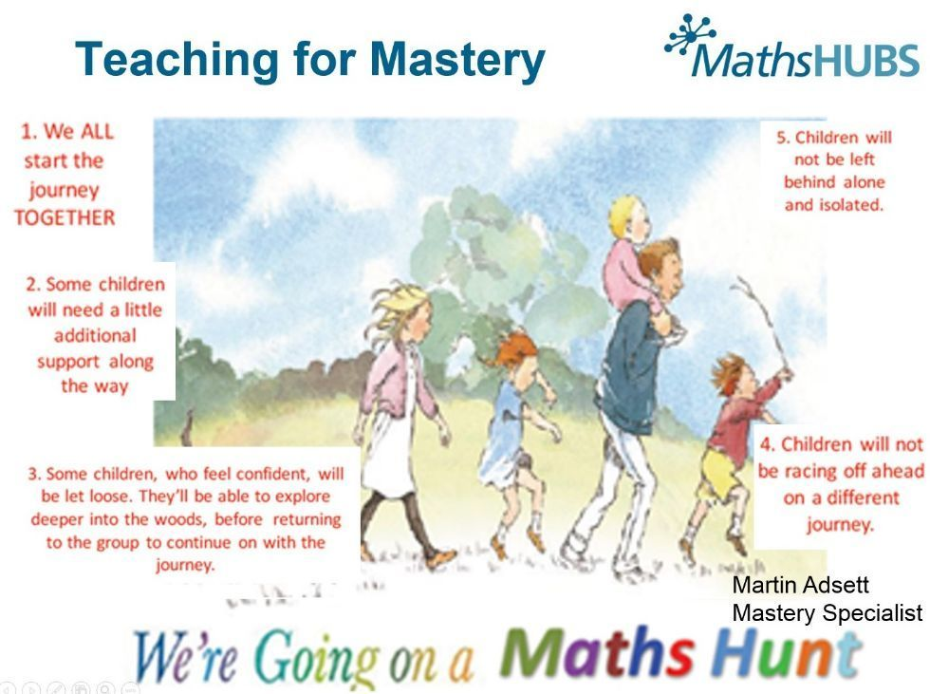

What's different now when teaching for maths mastery?
1. Seating - children sit in mixed-ability groups with a wide range of attainment on each table.
2. Planning - rather than planning for different attaining groups and their next steps in learning, we plan to take the whole class on a journey.
3. Time and steps - we spend longer on key units (number-based) and explore these in much greater depth.
4. Lesson structure - all lessons have just one learning objective/steps are now structured in micro-steps to achieve that goal.
5. Differentiation of work - we now all do the same work. Compared to previous teaching, this can be summarised as ‘Doing something different (beforehand) Vs Doing the same thing differently (now)’.
6. Depth - we provide opportunities for children to explore depth. Children are encouraged to think deeply and to make connections to different areas of mathematics, using conceptual and procedural fluency to apply knowledge to new situations and new contexts.
7. Repetition - lessons encourage use of repetition using precise mathematical language to embed learning.
9. Questioning - the ‘correct answer’ is no longer the end-point. Children are asked to explain their answer: “How do you know?” or “Explain your understanding” or “Convince me”.
10. Answering in full sentences - children must answer questions in full sentences using modelled stem sentences. This gets children to think and consolidates their understanding.
11. Conversations between children - children work closely with their partners and others on their tables, having the same sorts of conversations modelled during teaching.
12. Little teachers - children have multiple opportunities throughout the lesson to explain their thinking to the rest of the class, often using the interactive white board.
13. Work in books - this now looks very different to before. Children focus on depth of understanding - variation not variety.
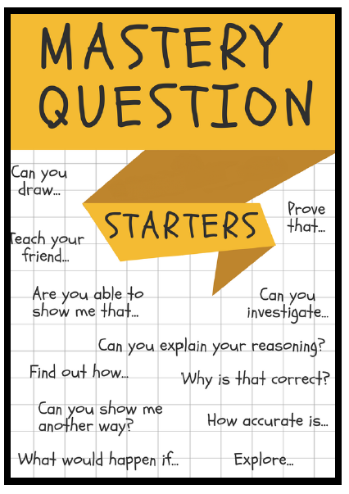
Providing Opportunities to Explore Depth
- Empty Number boxes;
- Present the same thing differently;
- True or False statements;
- Show me another way, and another ...
- Word Problems – solve and write your own;
- Draw an image that represents the maths;
- Write a calculation that represents an image;
- Write an explanation;
- Teach a friend.

