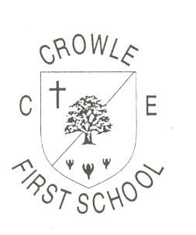

Maths Glossary

Our teaching sequence, to deepen children’s understanding:
- Concrete – Objects
- Pictoral – Drawing pictures to represent objects
- Abstract – Writing the number/equation/answer

Part/Whole
The whole number is the total. This can be broken down in to different parts:
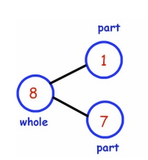
8 is the whole number but the parts are 1 and 7
The whole number never changes, it’s the parts that change.
The whole number will always be 8, but the parts could be 6 and 2 OR 5 and 3.

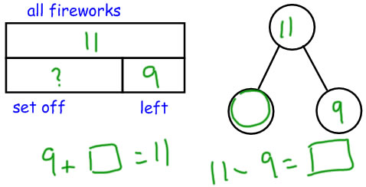
You can then use your part/whole knowledge to find a missing number.
You know what the “whole number” is, and you know what one of the parts – so what is the missing number?

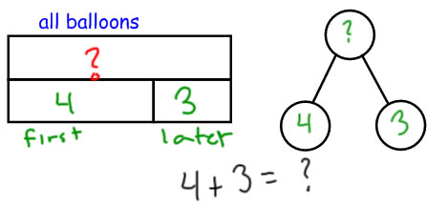

Using your “part/whole” knowledge you can then use this information to find
the “whole number”
You know the parts and use this information to find the whole number.

Regrouping
We group numbers to make them easier to work with. Because we use a base-10 number system, we group numbers in multiples of 10. Ten 1s are the same as one group of 10. One hundred 1s are the same as one group of 100.
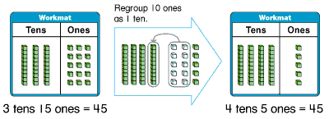

Sometimes, however, numbers are easier to work with if we regroup them -- arrange them into different groups.

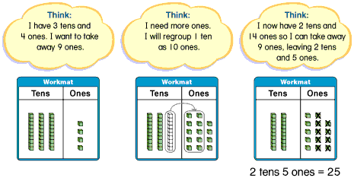

You regroup in some addition problems too.

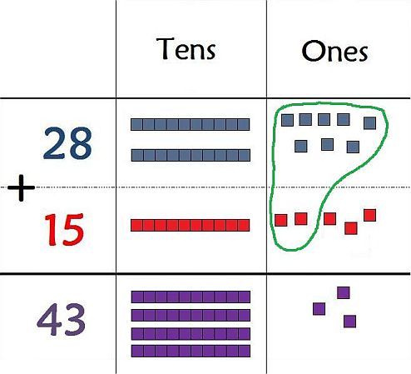

Value Counters
These are circular counters that represent different numbers. It is a pictoral representation of a number.

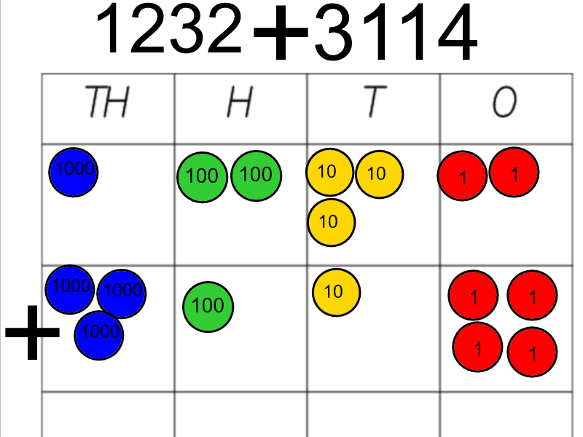

Partitioning
Partitioning is breaking a number down to their separate parts. Example: 52 is 5 tens and 2 ones.
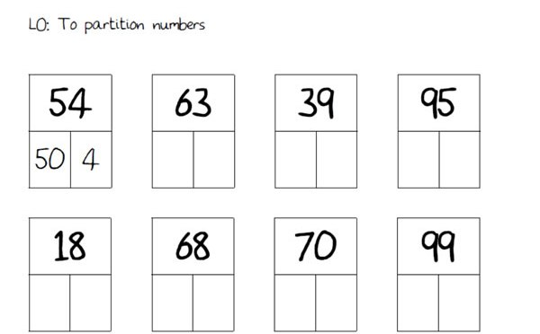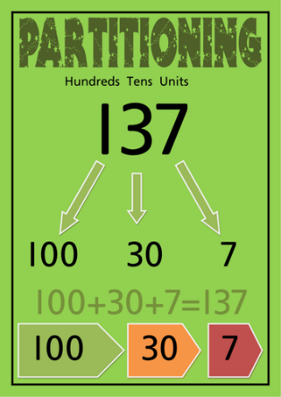

Children then use this knowledge to support them with adding/subtracting numbers
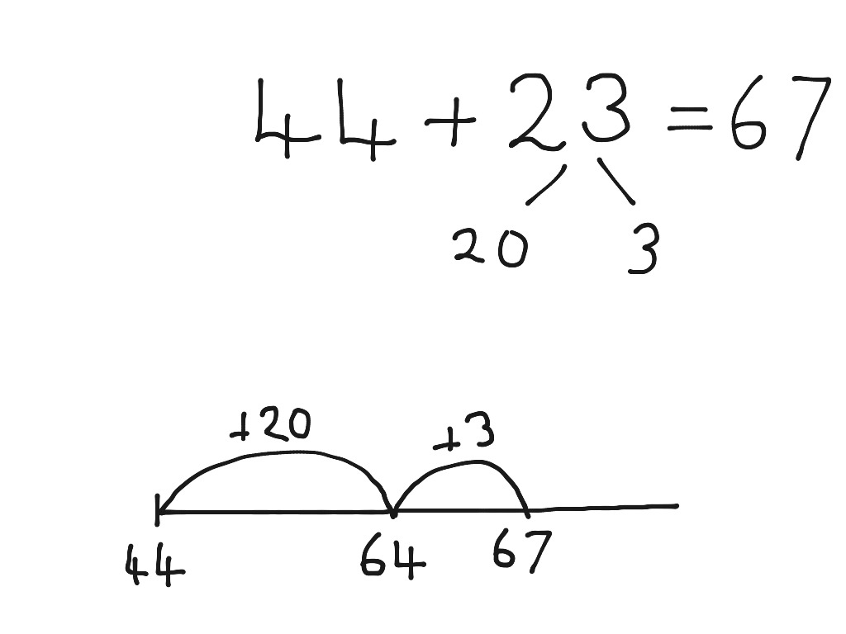

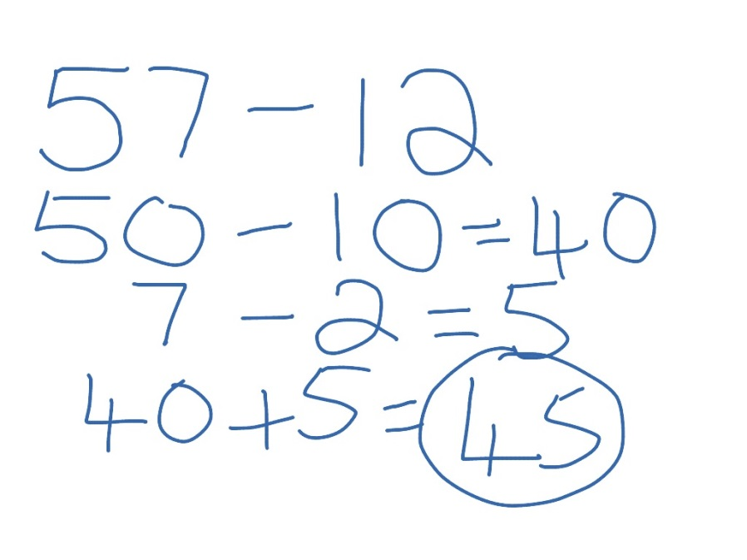

Bar model
A bar model is a way of visualising a problem, to find an answer.
Initially children start by representing numbers as a bar:

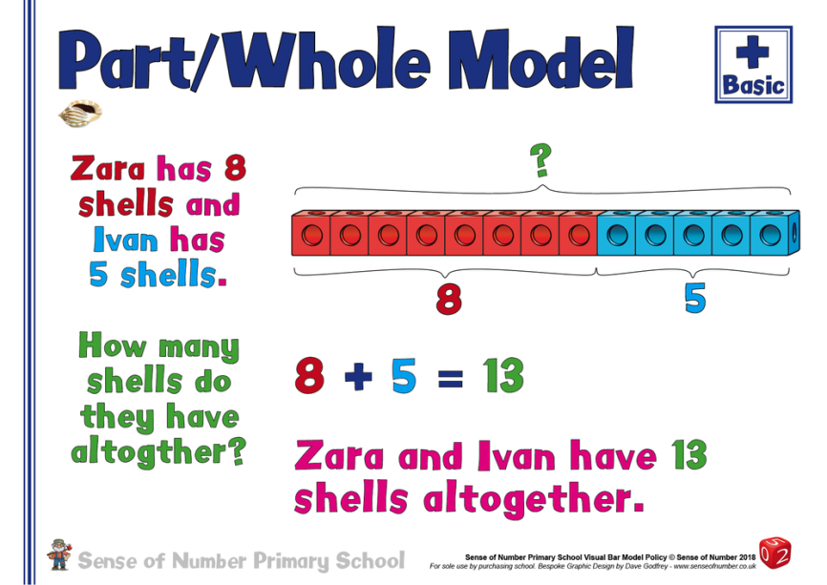

Children then begin to answer a range of problems, using a bar model to help them visualise the answer.
