Maths Glossary

Our teaching sequence, which aims to deepen children’s understanding:
- Concrete – Objects
- Pictoral – Drawing pictures to represent objects
- Abstract – Writing the number/equation/answer

Part/Whole
The whole number is the total. This can be broken down in to different parts:
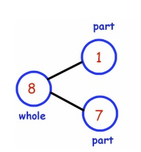
8 is the whole number but the parts are 1 and 7
The whole number never changes, it’s the parts that change.
The whole number will always be 8, but the parts could be 6 and 2 OR 5 and 3.

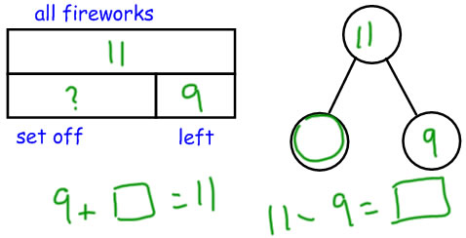
You can then use your part/whole knowledge to find a missing number.
You know what the “whole number” is, and you know what one of the parts – so what is the missing number?

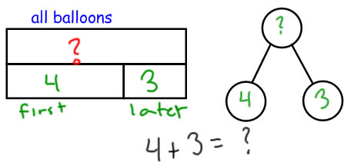

Using your “part/whole” knowledge you can then use this information to find the “whole number”
You know the parts and use this information to find the whole number.

Exchanging
We exchange numbers to make them easier to work with. Because we use a base-10 number system, we group numbers in multiples of 10. Ten 1s are the same as one group of 10. One hundred 1s are the same as one group of 100.
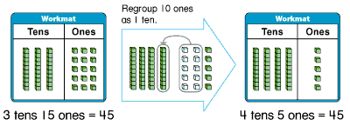
Sometimes, however, numbers are easier to work with if we exchange them -- arrange them into different groups.
Think:
I need more ones. I will exchange 1 ten for 10 ones.
Think:
I now have 2 tens and 14 ones so I can take away 9 ones, leaving 2 tens and 5 ones.
Think:
I have 3 tens and 4 ones. I want to take away 9 ones.
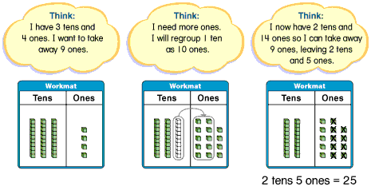

You can exchange in some addition problems too.
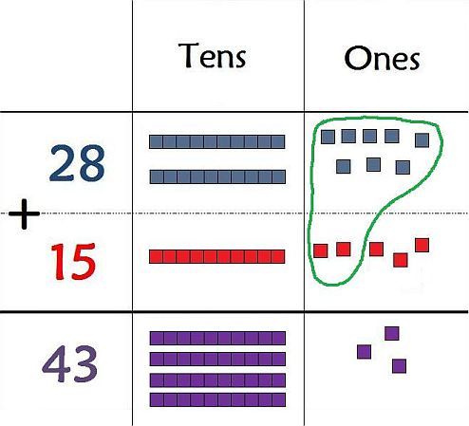
Place Value Counters
These are circular counters that represent different numbers. It is a concrete representation of a number. They can also be drawn to become a pictorial representation of a number.

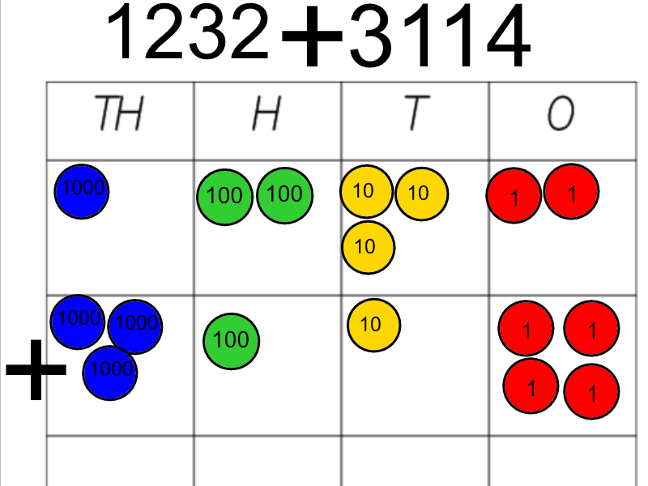

Partitioning
Partitioning is breaking a number down to their separate parts. Example: 52 is 5 tens and 2 ones.
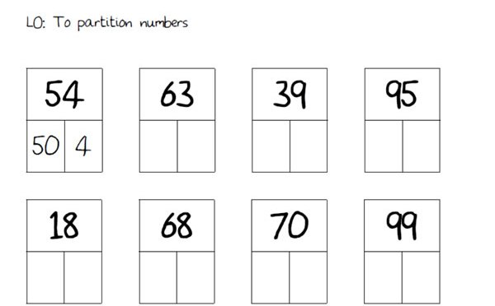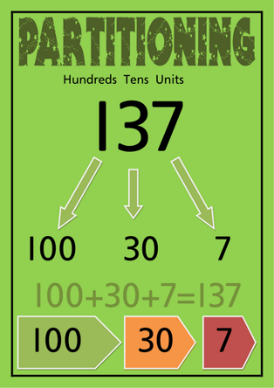

Children then use this knowledge to support them with adding/subtracting numbers
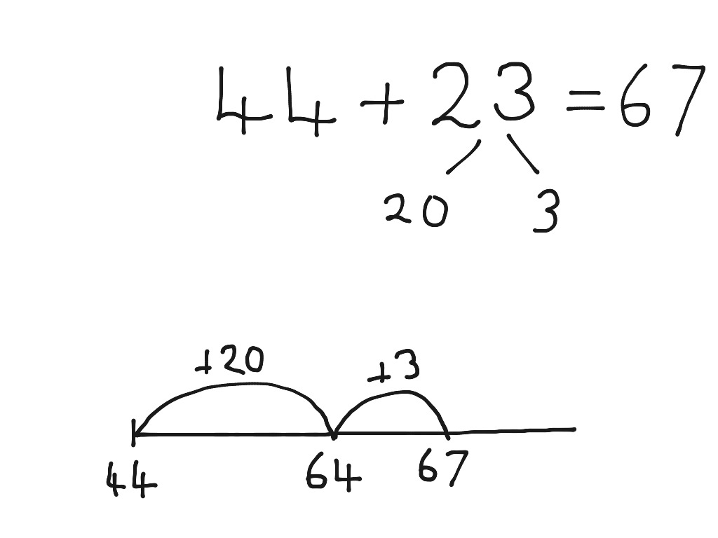
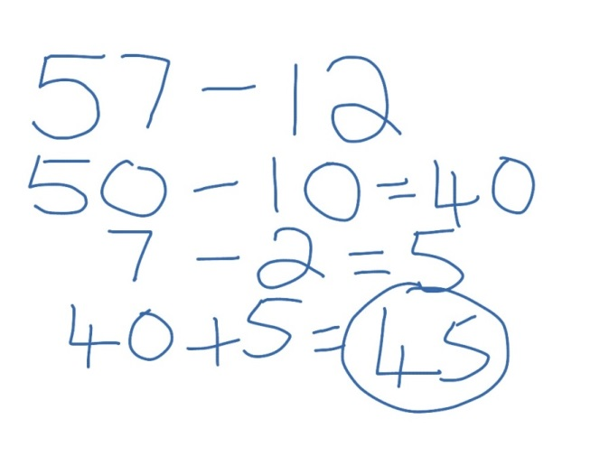

Bar model
A bar model is a way of visualising a problem to help find an answer.
Initially, children start by representing numbers as a bar:

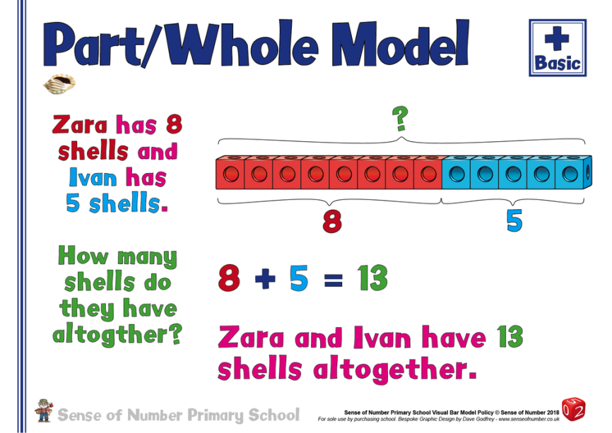

Children then begin to answer a range of problems using a bar model to help them visualise the answer.
