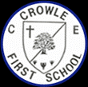
Crowle CE First School
Art Morning Planning
The progression grid outlines the specific knowledge which pupils are expected to learn in each phase, over a two year cycle, along with the specific vocabulary which supports this understanding.

Throughout the Art and Design learning, pupils will:
A1 Study the work of a range of great artists, craft makers and designers and understand the historical and cultural development of their art forms.
A2 Evaluate and analyse creative works using the language of art, craft and design.
Exploring and developing ideas
Skills | At EYFS: |  | At Key Stage One:  E1 record and explore ideas from first hand observations.  E2 ask and answer questions about starting points for their work.  E3 develop and share their ideas, try things out and make changes.  E4 describe the differences and similarities between different practices and disciplines, and making links to their own work.  E5 think critically about their art and design work. |  | At Lower Key Stage Two:  E1 create sketch books to record their observations and use them to review and revisit ideas.  E2 record and explore ideas from first hand observations, experience and imagination and ideas for different purposes.  E3 question and make thoughtful observations about starting points and select ideas for use in their work, recording and annotating in sketchbooks.  E4 think critically about their art and design work. | At Upper Key Stage Two:  E1 create sketch books to record their observations and use to review and revisit ideas.  E2 record and explore ideas from first hand observations, experience and imagination and ideas for different purposes.  E3 question and make thoughtful observations about starting points and select ideas for use in their work, recording and annotating in sketchbooks.  E4 think critically about their art and design work.
Drawing
Skills |  | At EYFS:  They represent their ideas and thoughts and feelings through DT, art (ELG)  Begins to develop a level of detail in their drawings using accuracy and purpose e.g. a facial features, fingers and small details – glasses, eyelashes freckles | At Key Stage One:  D1 experiment with and control marks made with different media: pencils, rubbers, crayons, pastels, felt tips, charcoal, ballpoints, chalks.  D2 draw lines and shapes using different surfaces.  D3 invent lines and shapes in drawing.  D4 to draw from imagination and experience | At Lower Key Stage Two:  D1 draw for a sustained periods of time.  D2 use a sketchbook to collect and develop ideas from a range of sources  D3 experiment with marks and lines with a wide range of implements e.g. charcoal, chalk, pencil, crayon, pens etc.  D4 experiment with different grades of pencil to achieve varied tone  D5 create texture and pattern in drawing with a range of implements. |  |  | At Upper Key Stage Two:  D1 work on sustained, independent, detailed drawings.  D2 develop close observational skills.  D3 use a sketchbook to collect and develop ideas.  D4 use different techniques for different purposes i.e. shading, hatching, and blending.  D6 begin to develop an awareness of composition, scale and proportion i.e. foreground, middle ground, background.
Painting and Printing
Skills |  | At EYFS:  Choose particular colours for purpose (40- 60mnths)  Mixes colours for purpose and apply this to their creation e.g. a pink pig | At Key Stage One:  P1 use a variety of tools and techniques i.e. brush sizes and types.  P2 experiment with tools and techniques e.g. layering, mixing.  P5 name and mix primary colours, shades and tones.  P6 create textured paint by adding material, i.e. sand or plaster  PR1 print with a range of hard and soft materials e.g. corks, sponge, fruit and vegetables.  PR2 take simple prints i.e. mono-printing.  PR3 create simple printing blocks for press print.  PR5 experiment with overprinting motifs and colour | At Lower Key Stage Two:  P1 experiment with different effects and textures including blocking in colour, washes, thickened paint creating textural effects, adding depth and distance.  P2 create different effects and textures with paint.  P3 use language of and mix primary and secondary colours and use tints and shades.  PR1 create printing blocks using relief or impressed method.  PR2 develop print techniques i.e. mono-printing, block printing, relief or impressed method.  PR3 create repeating patterns.  PR4 print with two colour overlays. |  |  | At Upper Key Stage Two:  P1 develop a painting from a drawing.  P2 experiment with different media and materials for painting. P3 create imaginative work from a variety of sources e.g. observational drawing, music, poetry, other artists  P4 mix and match colours to create atmosphere and light effects.  P5 identify, mix and use primary, secondary, complimentary and contrasting colours.  PR1 create printing blocks using sketchbook ideas.  PR2 develop techniques  PR5 experiment with overprinting motifs and colour.
Sculpture
Skills |  | At EYFS:  Understand that different media can be combined to create new effects (40-60months)  Uses various materials to represent objects/models e.g. Pipe cleaners for spider’s legs.  Constructs with a purpose in mind using a variety of purposes ( EAD 40-60mnths)  Using block to represent things with a defined name and purpose | At Key Stage One:  3D1 manipulate malleable materials in a variety of ways i.e. rolling, joining and kneading.  3D2 explore sculpture with a range of malleable media.  3D3 work safely with materials and tools.  3D4 experiment with constructing and joining recycled, natural and manmade materials | At Lower Key Stage Two:  3D1 plan, design and make models from observation or imagination.  3D2 develop skills in joining, extending and modelling clay.  3D3 use papier mache to create simple 3D effects.  3D4 experiment with constructing and joining recycled, natural and manmade materials.  3D5 create textures and patterns in malleable materials including clay. |  |  | At Upper Key Stage Two:  3D1 shape, form, model and construct from observation and imagination.  3D2 plan a sculpture through drawing and other preparatory work.  3D3 develop skills in using clay including slabs, coils, slips etc.
Textiles and Collage
Skills |  | At EYFS:  They safely use and explore a variety of materials, tools and techniques, experimenting with colour, design, texture, form and function. (ELG)  Use materials available to them to create/construct with a purpose e.g. making a handbag, robot | At Key Stage One:  T1 choose fabrics/threads based on colour, texture and shape.  T2 apply shapes with glue or stitching.  T3 apply decoration using beads, buttons, feathers etc.  T4 apply colour with printing, dipping, fabric crayons.  T5 create fabrics by weaving materials, i.e. grass through twigs.  C1 arrange and glue materials to different backgrounds.  C2 fold, crumple, tear and overlap papers. | At Lower Key Stage Two:  T1 use a variety of techniques e.g. printing, dyeing, weaving and stitching to create different textural effects.  T2 develop skills in stitching, cutting and joining  C1 experiment with a range of collage techniques such as tearing, overlapping and layering to create images and represent textures.  C2 use collage as a means of collecting ideas and information and building up a visual vocabulary. |  |  | At Upper Key Stage Two:  T1 use fabrics to create 3D designs  T2 experiment with a range of media to overlap and layer creating textures, effects and colours.  C1 use a range of media to create collages.  C2 use different techniques, colours and textures when designing and making pieces of work.  C3 use collage as a means of extending work from initial ideas.

Key Stage One Cycle A
 | London’s Burning! | We are the United Kingdom! | Poles Apart
Key Knowledge | David Best – the man who builds art and then burns it  David Best (born 1945) is an internationally renowned American sculptor. He is known for building immense temples and cityscapes out of recycled wood. They are then burnt to the ground in a spectacle of light and heat.  ‘London 1966: Watch It Burn’ - Best created wooden structures with the help of scores of young volunteers from across London. The huge sculpture, measuring over 120 metres in length, provided a dramatic image of a 17th century London skyline.  On 4th September 2016 the model was mounted onto barges and floated down the River Thames before being burned in front of a huge audience for the 350th anniversary.  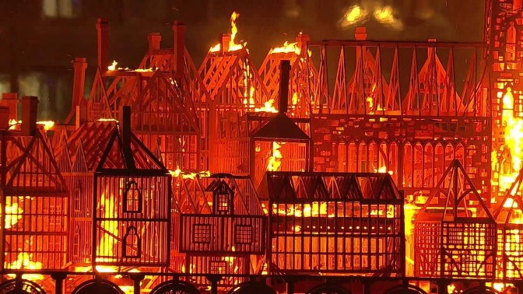 | Chris Levine  Chris Levine was born in Canada but now lives and works in Northamptonshire, UK.  He works across many disciplines but always with some form of light - lasers, holograms, etc (google films on him to gain further understanding)  He is perhaps best known for producing what is one of the most iconic images of the 21st century, ‘Lightness of Being’. This sensational portrait of Her Majesty Queen Elizabeth II presents a totally fresh depiction of the most famous woman in the world.  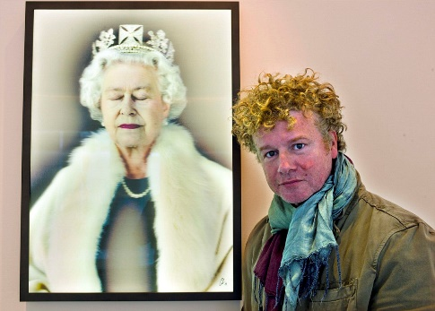 | Julie Dumbarton and Christa Rijneveld  Julie Dumbarton is based in south west Scotland and is a prolific painter of landscapes and skies. Colour plays an important part in her work.  Christa Rijneveld grew up on a Dutch dairy farm drawing at the kitchen table. At the age of eighteen she applied to art school and didn't get in. She felt defeated and gave up on the idea of becoming an artist.  In 2015 she decided to leave Europe and move to a small town in British Columbia, Canada. The hustle and bustle was replaced by the beauty and stillness of the scenery: the Rocky Mountains. It was something she had never experienced before.  She’s greatly inspired by the mountains – the soft curves, sharp edges, layers and shapes.  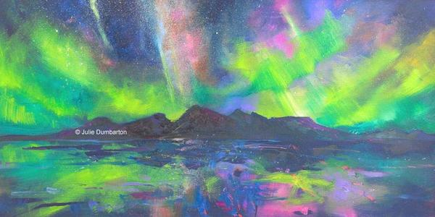

Key Stage One Cycle A
 | Time Travellers | Chocolate | Sensational Safari
Key Knowledge | William Morris  A British textile designer, poet, novelist, printer and social activist. He lived from 1834 – 1896.  He believed that art should be present in everyday objects like textiles and homeware, and everyone should be able to have arts and crafts in their life.  Over the course of his life, he had a huge impact on art and design and many of his wallpapers and textiles are still being made today.  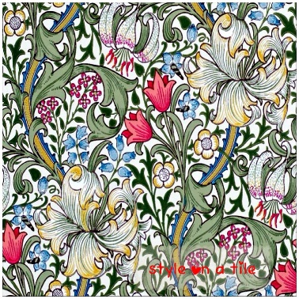 | Andy Warhol  Andy Warhol was an American visual artist and a leading figure in the “pop art” movement. He lived from 1928 – 1987. Some of his best-known works include the silkscreen paintings Campbell's Soup Cans (1962) and Marilyn Diptych (1962) and the multimedia events known as the Exploding Plastic Inevitable (1966–67).  Warhol initially pursued a successful career as a commercial illustrator. After exhibiting his work in several galleries in the late 1950s, he began to receive recognition as an influential and controversial artist. His New York studio, The Factory, became a well-known gathering place for artists to share ideas and inspirations.  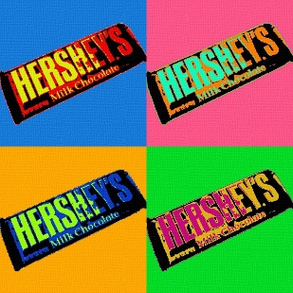 | Martin Bulinya  Martin Bulinya was born in Kenya. He began drawing in charcoal and pencil early at age and his talent blossomed in primary school where he won many local awards. He went on to study art at the University of Niarobi.  His paintings show groups of Masai people in lots of different situations and poses. He gives his paintings simple backgrounds so that the people stand out. The people are given highly detailed clothing with lots of different colours and patterns.  You might notice that the characters in his paintings are not standing still. They all have different emotions and some even look like they are talking to each other.  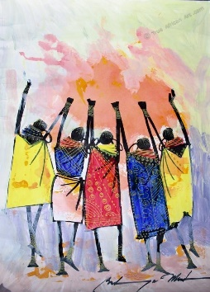

Key Stage One Cycle B
 | Great Explorers - We’re off on an adventure! | A Toy Story | Roar!
Key Knowledge | Emily Garfield  Emily Garfield is an American artist. She creates intricate maps of imaginary places that explore the origins of cities and the function of maps themselves. She uses pen and watercolours.  Her drawings are inspired by the visual language of maps and the fractal similarity that cities share with biological processes such as the patterns of cells and neurons.  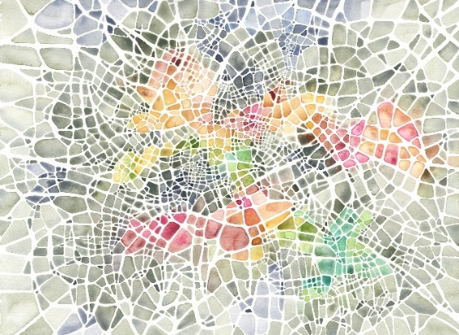 | Emma O’Brien  Emma lives in Coventry. She is an illustrator and maker of monsters. She draws illustrations every day, exploring things like monsters, outdoor swimming, cities and family.  She has been designing and making monsters since 2008. The first monster was a bit of an accident while she was doing her MA in soft sculpture and shapes, they’ve all just evolved since then. They all have their own special character and she sells them in shops and online.  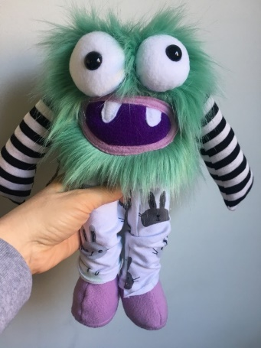 | Yann Arthus-Bertrand  Yann Arthus-Bertrand was born in 1946 in France and is perhaps the best known aerial photographer of all time.  He has travelled the world documenting the beauty of the planet. He is especially famous for his book The Earth From Above which documents captured views of the earth from the sky over a 10 year period. His pictures show us the beauty of the natural world.  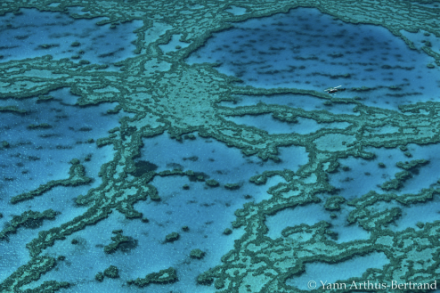

Key Stage One Cycle B
 | Street Detectives | Nurturing Nurses | Oh we do love to be beside the seaside!
Key Knowledge | Banksy  Banksy is a famous, but anonymous, British Graffiti artist. He keeps his identity a secret.  He produces pieces of art which pop up in public places, such as the walls of buildings. He uses a lot of stencils to produce the images. This allows him to paint detailed pictures in a short amount of time. It enables him to keep his true identity a secret too.  He began spray-painting trains and walls in his home city of Bristol in the early 1990s. Bristol is well known for its colourful street art and graffiti. In 2000 he expanded his work beyond Bristol and was soon leaving his mark all over the world. His artwork carry a lot of political messages.  Some don’t support what he does and call it vandalism.  There is debate about why Banksy’s work is called ‘art’ when other graffiti artists get into trouble and are prosecuted for doing the same thing.  When he leaves artwork on buildings there can sometimes be arguments about who owns it and what should be done with them, as they are very valuable.  Painting on walls though is not something new. Some 20,000 years ago, early humans ground up earth, charcoal, and minerals, and used the coloured powders to create images on cave walls. Sometimes the powders were mixed with saliva or animal fat to form a fluid, which was blown through reeds, or applied with fingers.  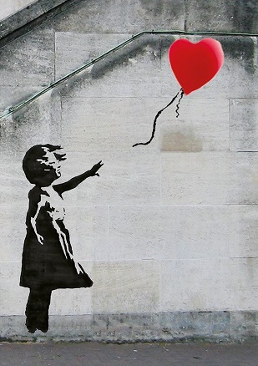 | Henrietta Rae  Henrietta was born in London, in 1859. She formally began studying art at the age of thirteen and she was the first female student that attended her art school.  She painted “Lady with the Lamp” with oil colours (based on Florence Nightingale in the Crimean War) in 1891.  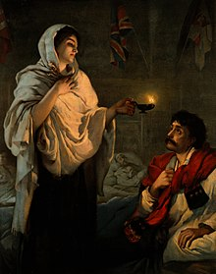 | William Turner  William Turner (1775 – 1851) was an English painter known for his expressive, imaginative landscapes and turbulent marine paintings.  He lived all his life in London but travelled widely returning with huge sketchbooks full of ideas. He was shy and reclusive.  As his personal style developed, he began to produce paintings that were full of movement and expressive colour rather than being realistic. He became interested in natural catastrophes, and natural phenomena such as sunlight, storms, rain, and fog. He was fascinated by the violent power of the sea  He left behind 2,000 paintings and 19,000 sketches.  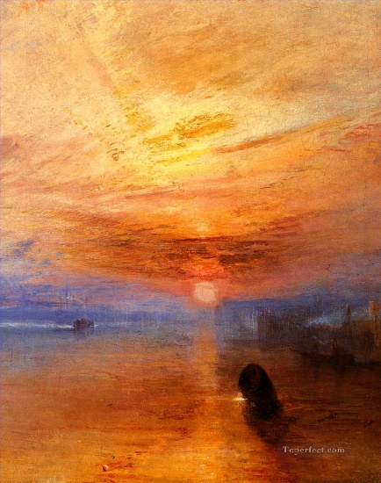

Key Stage Two Cycle A
 | Exciting Egyptians | Natural Disasters – Get me out of Here! | The World’s Kitchen
Key Knowledge | Alaa Awad  Born in 1981, Alaa Awad is an Egyptian painter and muralist based in Luxor.  Inspired by ancient Egyptian heritage and contemporary society, some of Awad’s most popular work includes scenes of celebration, victory, Egyptian social life and culture.  He is especially well known for his large-scale, public murals in Cairo and Luxor.  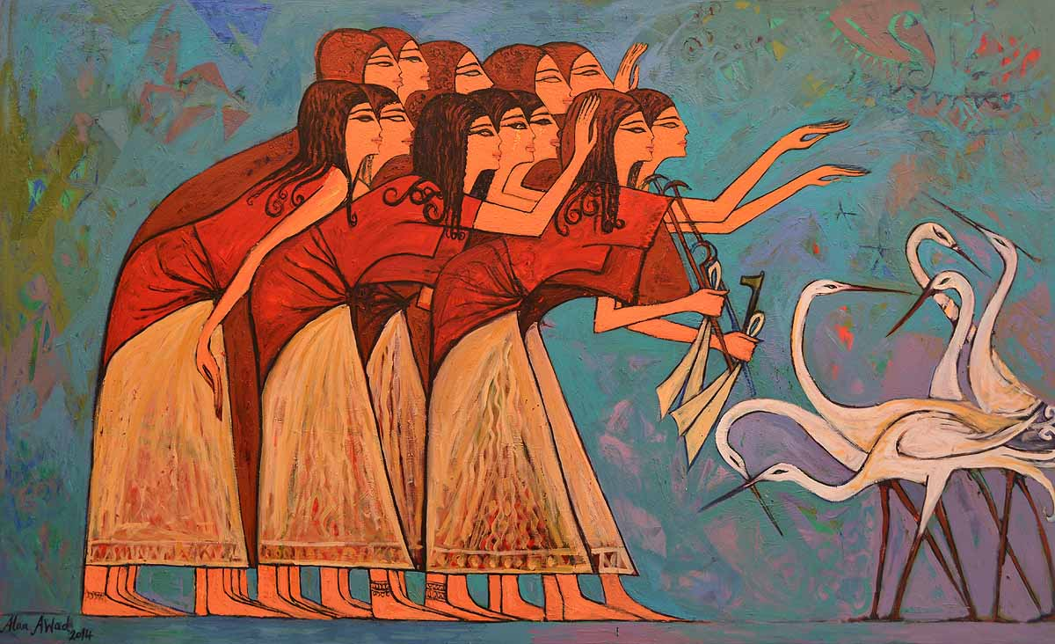 | Stephanie Peters  An American artist inspired by natural disasters and animals. She works with mixed media to create bold and colourful works of art that she hopes will encourage people to reconnect and fall in love with nature again.  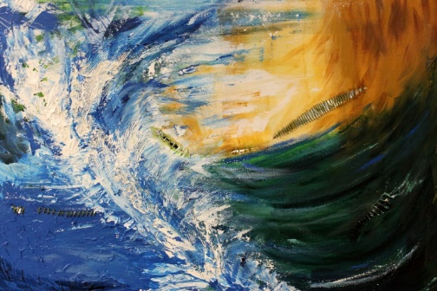 | There is no art focus in this topic – DT - cooking

Key Stage Two Cycle A
 | Anglo-Saxons | Rainforests | Stone Age
Key Knowledge | Judith Scott  Judith Scott (1943 – 2005) was born in Ohio, USA. She is known internationally for her art.  She had a twin sister named Joyce. Unlike Joyce, Judith was born with Down Syndrome and during her infancy Judith contracted Scarlet Fever, which caused her to lose her hearing, a fact that remained unknown until much later on in her life.  Judith spent her first seven and a half years at home with her parents, twin sister and older brothers. However, when it was time for the girls to start school, Judith was not able to pass the entrance tests, due to her undiagnosed deafness. Consequently, on medical advice, her parents placed her in the Columbus State Institution. This separation had a profound effect on both twins.  Judith was denied any training opportunities and deprived of her twin. She became sad, unhappy and very lonely.  In 1985, after 35 years of complete separation and lengthy and difficult negotiations, Joyce Scott brought Judith to live with her. She started to attend art classes and it was soon recognised that she had a great talent. Using the materials at hand, Judith invented her own unique form of woven sculpting. She would sit for hours in her own world, quietly creating with intense concentration.  Her creative gifts and focus were quickly recognised, and she was given complete freedom to choose her own materials. Taking whatever objects she found she would wrap them in carefully selected coloured yarns to create sculptures of many different shapes. Many of her works also feature pairs, reflecting Scott's experience as a twin.  Judith worked on her art five days a week for eighteen years, producing over 200 pieces in total.  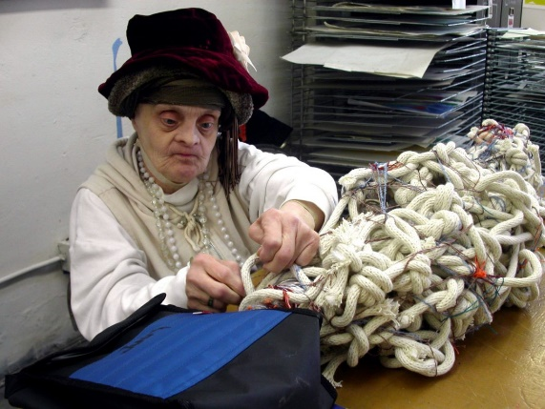 | Oenone Hammersley  Oenone Hammersley was born in England in 1957 and is now a successful contemporary artist. She has been exhibiting since 1980. Her abstract and semi-abstract paintings in oil and mixed media on canvas focus on our natural resources in particular water and trees.  Oenone Hammersley is best known for her rainforest and wildlife paintings. Oenone spent three years living in Tanzania painting African wildlife. She also spent two years living in Australia and traveled to Papua New guinea to paint the birds of paradise prior to her exhibition on the birds and frogs of Australia.  Colour and light are used to emphasize the vanishing world of wilderness that implores us to take notice, appreciate the rare and raw beauty about us, and allow our imagination to roam about the abstract compositions symbolizing the unsettled and unsettling world in which man alters nature.  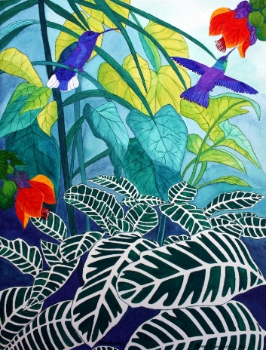 | Jon Foreman  Jon is based in Pembrokeshire, Wales. He is a Land Artist creating works in mostly natural material. His work is nearly always short lived as the elements, sea, wind, and sometimes sun, make them disappear.  Most of his work is formed of stones. He gathers them in different sizes, shapes and colours and arranges them in eye-catching formations. From giant circles, dynamic swirls and other intricate patterns, Foreman’s work reveals the unique beauty of stones  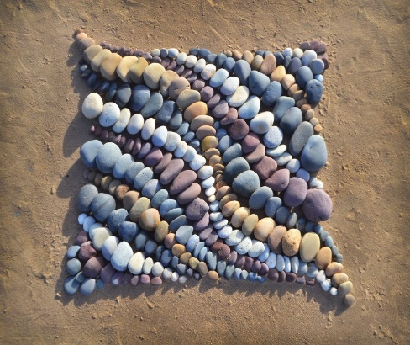

Key Stage Two Cycle B
 | Rampaging Romans | Birmingham vs Crowle | Marvellous Mayans
Key Knowledge | Antoni Gaudi  Antoni Gaudí (1852 – 1926) was a Spanish architect  Gaudí's works are in his own distinctive style. Most are in Barcelona, especially his greatest work, the Sagrada Família. His work has an organic style, inspired by nature.  Gaudí favoured the trencadis technique of mosaic art, which used irregular pieces of ceramic, glass or marble tiles. Very similar to Mango Mosaics technique!  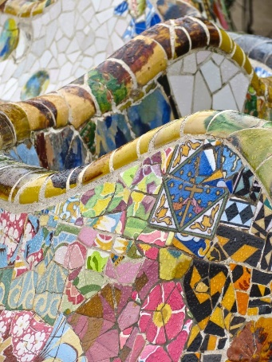 | Stephen Wilshire  Stephen Wilshire is an artist who has a talent for drawing life-like, accurate cityscapes, sometimes after only briefly observing them. He has an incredible memory!  He was born in London to West Indian parents in 1974 and as a child he was mute and did not relate to other people. At aged 3 he was diagnosed with autism.  When he went to school he still wasn’t speaking and communicated only through drawings. He first word was ‘paper’. He began to speak fully at 9 years old.  He was 7 when he sold his first piece of work and at aged 8 he was commissioned by the British Prime Minister to create Salisbury Cathedral.  He has travelled the world and become very famous.  Stephen continues to draw everyday and his motto is ‘Do the best you can, and never stop’  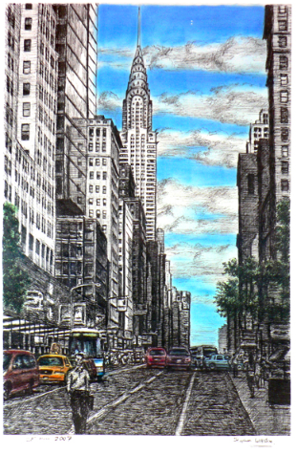 | Richard Mazzola  Inspired by the symbolism of the ancient Maya, artist Richard Mazzola has transformed their iconic glyphs into his own modern art, using oils, acrylics and mixed-media.  For 25 years, Mazzola and his wife, Cami, travelled and lived among the modern-day Maya in the Yucatan Peninsula.  They became fascinated with Maya ruins, Maya beliefs and the beautiful environment. These influences led Mazzola to create his Mayan Series of paintings, which he is now sharing with the public.  The works are filled with symbolism reflecting ancient beliefs. The Maya symbols include the celestial snake representing birth; the quetzal bird, a symbol of the heavens; the jaguar, the greeter to the afterlife; Maya death masks, for courageous warriors; and crosses, birth and rebirth.  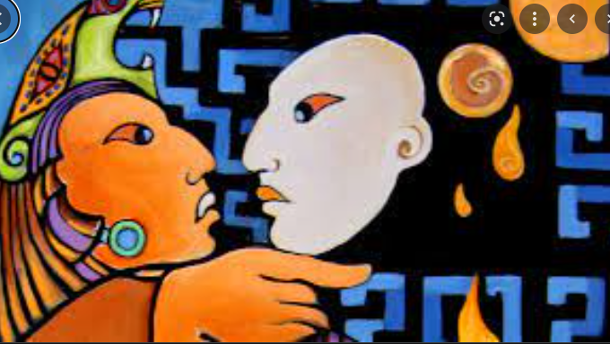

Key Stage Two Cycle B
 | Kids Against Plastic | Are Norman Castles Bouncy? | Water. Water Everywhere
Key Knowledge | ‘The Bristol Whale’ - Cod Steaks  (lots of good films available on google)  Cod Steaks are a group of artists based in Bristol. They do lots of projects as a team. They are particularly well known for their animation projects but in 2015 decided they needed to do something which focused in on environmental issues.  ‘The Bristol Whale’ was a temporary art installation in the centre of Bristol that highlighted the beauty and fragility of the oceans, and humanity’s impact on them. It was situated in Bristol’s Millennium Square between 17 July and 1 September 2015. It focused on the detrimental effect of plastic pollution and encouraged a reduction in the consumption of single-use plastics.  The sculptures of the two, life size whales were created using recycled and sustainable materials. They were made from willow harvested locally in Somerset and the whales are swimming through an ‘ocean’ of 70,000 plastic bottles, collected from the Bath half marathon and the Bristol 10k race. Their construction also involved thousands of people in the South West, including 150 Bristol school children.  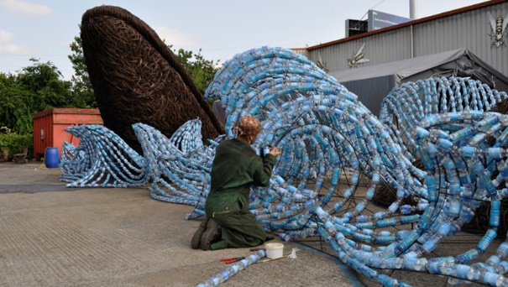 | John Piper (1903 – 1992)  He was an English painter, printmaker and designer of stained-glass windows and both opera and theatre sets. His work often focused on the British landscape, especially churches, castles and monuments. Piper was an official war artist in World War II and his wartime depictions of bomb-damaged churches and landmarks, most notably those of Coventry Cathedral, made him very famous.  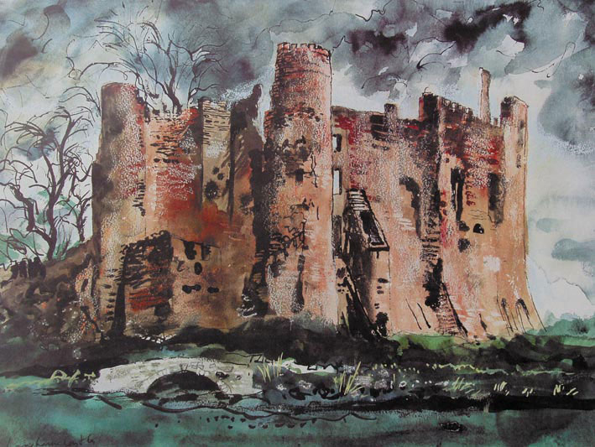 | Zaria Forman  (lots of films available on google)  Born in New York, USA, in 1982, Zaria Forman documents climate change with large, photorealistic pastel drawings. Her work focuses on the problems of water conservation, melting polar ice, and rising sea levels.  She travels to remote regions of the world to collect images and inspiration for her work, which is exhibited worldwide. She has flown with NASA on several missions over Antarctica, Greenland, and Arctic Canada. She was featured on CBS Sunday Morning, CNN, PBS, and BBC. She delivered a TEDTalk, and spoke at Amazon, Google, and NASA’s Goddard Space Flight Centre, exhibited in Banksy’s Dismaland, and was the artist-in-residence aboard the National Geographic Explorer in Antarctica.  

