Crowle CE Primary School

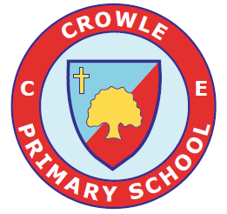



Family Support Offer

Reviewed: Sep 2025 |  | Review Date: Sep 2026

Crowle CE Primary School

The pupils of Crowle CE Primary School are caring, confident and committed to their learning.

Support for Children and Families

Early Help at Crowle CE Primary School

Key Personnel and job roles
Designated Safeguarding Lead: Mrs M Abbott
Deputy Designated Safeguarding Lead: Miss L Johnson and Mrs K Thomas
SENCO: Mrs C Stockford
Safeguarding Governor: Mrs K Jones
Contact details email: 01905 381 206

Our Family Support Offer
Family Support is a pathway to supporting you and your child as they grow up when you, or they, may need further support or guidance.

Providing early help to our pupils and families at Crowle CE Primary School means we can improve outcomes for children, families, and communities, providing support as soon as a problem emerges, at any point in a child’s life, from the early years through to teenage years.

Family Support can support children and their families who may be struggling with:
- Routines and family rules
- Families who may be not be eating healthy food
- Keeping to a healthy lifestyle
- Children who are caring for a family member
- Children who may not want to go to school for different reasons
- Disability within the family including children being a young carer
- Children in the family have special educational needs (SEND)
- Children who may becoming involved in anti-social or criminal behaviour
- Children who go missing from home
- Children or parents / carers misusing drugs or alcohol
- Children at risk of being tricked, forced, or made to work in the criminal world
- Children who may need support because they may live in a home and see drug or alcohol abuse or adult mental health problems.
- Children who have parents who argue a lot (and sometimes might hurt each other) whether the parents live together or apart.
- Children at risk of being groomed to join groups which support illegal views
- A privately fostered child (a child from another family living within your family home)

Family Support relies upon local groups and people in the community, sometimes we work together to help children, young people, and their families.

Everyone needs help at some time in their lives and therefore an ethos of early help is important for any school.
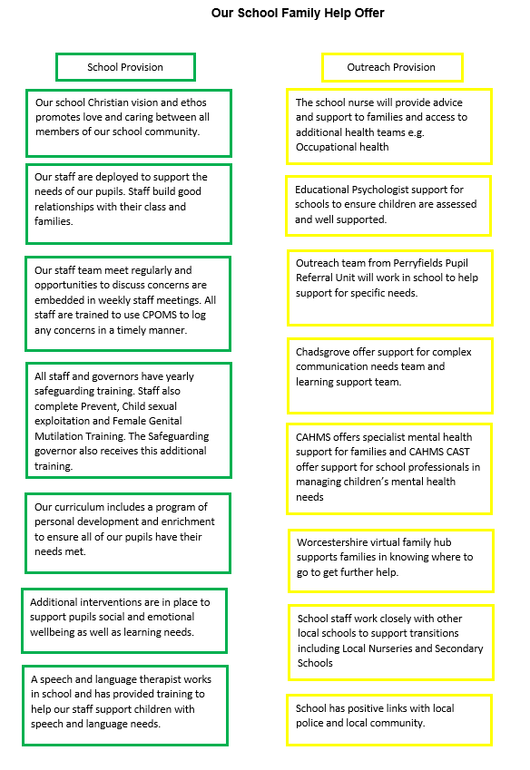

Local Services

Services local to Crowle CE Primary School include:
Virtual Family Hub  https://www.worcestershire.gov.uk/council-services/childrens-social-care/virtual-family-hub | What’s on during the school holidays?  Ready Steady Worcestershire Holiday Scheme  https://www.worcestershire.gov.uk/children-social-care/ready-steady-worcestershires-holiday-activities-and-food/ready-steady-worcestershires-holiday-activities-and-food  Holiday Activities and Food Programme  https://www.worcestershire.gov.uk/council-services/childrens-services/virtual-family-hub/holiday-activities-and-food-haf-programme
Youth Centre St Johns –  https://worcester.cylex-uk.co.uk/company/st--johns-youth-centre-13984288.html  Youth and Community Centre Malvern  https://www.malverncube.com/  Onside advocacy Your Space Wellbeing Drop Ins  https://www.onside-advocacy.org.uk/yourspace | Malvern Foodbank  https://malvernhills.foodbank.org.uk/
Early Help Family Support District Team – Worcester, Early Help Family Support  Worcestershire Children First Early Help Family Support Service | Worcestershire County Council  Team contact number: 01905 843339  Team email address: FamilySupportWorcester@worcschildrenfirst.org.uk  Malvern, Early Help Family Support  Team contact number: 01905 843961  Team email address: FamilySupportMalvern@worcschildrenfirst.org.uk | Malvern Library  https://www.worcestershire.gov.uk/directory_record/25/malvern_library

Early Help Family Support Service:
The Early Help Family Support Service is delivered by Worcestershire Children First directly to families permanently living in Worcestershire who have children aged 0-18 years old and need help and support specifically from a Family Support Worker. For more information, please visit: Worcestershire Children First Early Help Family Support Service | Worcestershire County Council

Support for Children and Families

Health (including mental health, emotional wellbeing, and sexual health)
The Starting Well Partnership offers a range of health services which support both children and families experiencing a range of health issues.

Starting Well Partnership | Worcestershire | Starting Well
If your child is under 5 years old and you need advice on issues such as feeding, behaviour, or toileting you can contact the Telephone Advisory Service on 0300 123 9551 (Monday – Friday 9am til 3pm). A Health Visitor will assist you over the phone with any worries, concerns, or questions you have.

Our services | School Health Nursing Service Worcestershire | Herefordshire and Worcestershire Health and Care NHS Trust
School health nurses offer a range of services such as home visits, health needs assessments, time4u drop-in service, school aged hearing and national child measurement programme to support the needs of children and their families.

ChatHealth | Starting Well
Chat health is a free and confidential text service for young people in need of advice or support
To confidentially contact your school nurse, text: 07507331750
Social Prescribing: Onside Advocacy, Worcestershire (onside-advocacy.org.uk)
Social Prescribers support you to take control of your health and look after yourself by making connections with the different types of community support available.

CAMHS | Herefordshire and Worcestershire Health and Care NHS Trust (hacw.nhs.uk)
CAMHS provides mental health help to children, young people and their families across Herefordshire and Worcestershire

Home - Kooth
Kooth is an online mental wellbeing community which offers free, safe, and anonymous support.
Helpful information for parents and carers | Herefordshire and Worcestershire CAMHS
The CAHMS team promotes positive wellbeing to reduce the stigma of mental health by providing short-term group programmes for children and young people age 5-18 experiencing mild to moderate anxiety and low mood.
Papyrus UK Suicide Prevention | Prevention of Young Suicide (papyrus-uk.org)
Papyrus can offer suicide prevent support providing free and confidential helplines, advice, webchats, and resources.

Home | Healthy Minds (whct.nhs.uk)
Healthy Minds’ 24/7 mental health helpline provides support or advice if you, or someone you know, is experiencing a mental health crisis and needs urgent help. Its available 24 hours a day to anyone in Herefordshire and Worcestershire.

Winston's Wish - giving hope to grieving children (winstonswish.org)
Winston’s Wish provide support for children and young people following the death of a sibling, parent, or a person important to a child.

Sexual Health Know Your Stuff | Sexual health | Worcestershire County Council
Worcestershire Integrated Sexual Health Service (WISH) | Herefordshire and Worcestershire Health and Care NHS Trust (hacw.nhs.uk)
WISH offer friendly and non-judgemental specialist services to support with information and advice, contraception, pregnancy, STIs and screening.

Under 21 Saturday Service - Clinic telephone lines are open between 10:00am – 12:30pm on Saturdays - Please call: 01905 681673 for further details.
Young People have a telephone consultation and are asked questions about their relationships. Callers will be advised what to do next and directed towards a clinic if necessary.
WISH have a dedicated Outreach nursing service. Referral forms can be found at www.knowyourstuff.nhs.uk. The Outreach team see young and vulnerable people who couldn’t otherwise access sexual health services.

Free STI test kits and contraception: SH:24 Free Home STI STD Test | Sexual & Reproductive Health (sh24.org.uk)

Bullying (including Cyberbullying)
If you are concerned your child or a child, you know is being bullied there are several services and useful links which can help you support your child as a parent.

In the first instance if bullying is happening at school, please speak to a member of staff who will be able to help.

The following links will provide you with more information if you or someone you know is being bullied:
https://www.worcestershire.gov.uk/sites/default/files/2022-12/v6_anti_bullying_01_2020.pdf

Online Safety
If you have concerns around the safety of your child or a child you know online, the following links will provide you with information, support, and advice to help understand the risks and keep your child safe online:
- Think U Know | Information for parents
- Online safety | Barnardo's (barnardos.org.uk)
- Educate Against Hate
- www.internetmatters.org
- BBC | 8 tips for staying safe online

Sexting is the sending or receiving of sexually explicit images, videos or conversations online.
Sexting and sending nudes | NSPCC
Think U Know | Parents Sexting Guide

Relationships
The following services and links offer information, advice, and intervention on healthy relationships for your family and children:
- Healthy relationships | NSPCC

- Challenges at home: https://www.worcestershire.gov.uk/council-services/childrens-social-care/virtual-family-hub/harmony-home

- CRUSH is an awareness raising and support programme to help young people make safe and healthy relationships. http://www.westmerciawomensaid.org/crush/

- https://www.worcestershire.gov.uk/council-services/childrens-services/virtual-family-hub/relationship-support

Friendships and relationship in teenagers
Making friends and starting new relationships are a big part of getting older. It's very common to fall out with friends or break up from relationships – which can be very difficult to deal with. You might also be in a relationship that doesn't feel right and need some advice about what to do. The websites below contain lots of information about making friends, peer pressure, healthy and unhealthy relationships, sex and much more. There is also information available for parents around how to talk to your child about friendships, sex and relationships.
Childline - Friends, relationships and sex (opens in a new window)
Disrespect Nobody - Signs to spot (opens in a new window)

SEND (Special Educational Needs and/or Disabilities)

If you are looking for information or advice the following links will help you:
SEND Local Offer | Worcestershire County Council or contact localoffer@worcschildrenfirst.org.uk

SEND Information, Advice, Support Service SENDIASS Worcestershire and Herefordshire (hwsendiass.co.uk)

Social care support for children with disabilities
https://www.worcestershire.gov.uk/council-services/childrens-services/childrens-social-care/social-care-support-children-disabilities



The Online Family Hub has been developed to provide you with a range of different types of resources that are available to you online, on the phone or face to face that you can access directly.

The Family Hub can offer you support and information with the challenge’s family life can bring.

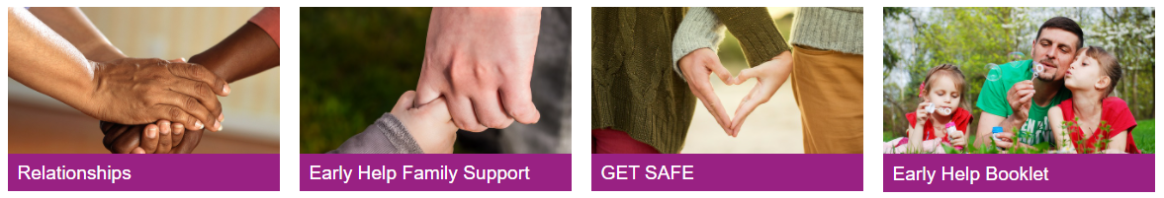
https://www.worcestershire.gov.uk/council-services/childrens-services/virtual-family-hub

Early Help in Worcestershire have created a booklet to help families find out about the help and support available in the county for children and young people aged 0-18 years old. The new booklet will help you and families find the most appropriate support.
To download this booklet, please visit: https://www.worcestershire.gov.uk/council-services/childrens-services/virtual-family-hub

Worcestershire Young Carers
Worcestershire Young Carers aim to identify, and support children and young people aged 7 to 24 years who have a caring role within the home and help look after a parent, sibling, or grandparent due to illness, disability, physical or mental health difficulties or substance misuse.
Worcestershire Young Carers/Shropshire Young Carers | YSS

https://www.worcestershire.gov.uk/council-services/adult-social-care/looking-after-someone-carer-support/young-carers-and-young-adult-carers

Finance, Housing and Employment
If you are facing challenges around employment and income, please contact the local job centre who can with offer support with jobseekers’ allowance, incapacity benefit, employment and support allowance and income support:

[Local] Job Centre Plus,

Worcester Job Centre Plus, Haswell House, Sansome Street, Worcester, WR1 1UZ
Telephone: 0845 6043719
Citizen’s Advice Bureau Worcester Citizens Advice Bureau and WHABAC (Worcester Housing and Benefits Advice Centre) (citizensadviceworcester.org.uk)
For information on what financial and housing support is available in Worcestershire, please visit:
https://www.worcestershire.gov.uk/council-services/childrens-services/virtual-family-hub/housing-finances-and-debt

Parenting Support
The Starting Well Partnership offer a range of parenting support, information, groups, and courses. For information on the groups available please visit: Parenting groups | Starting Well (startingwellworcs.nhs.uk)

Parenting Talk is an online hub offering information, advice, and a free confidential online chat with a parenting advisor.
Parent Talk - Support for Parents from Action For Children

Homestart can work with you to provide one to one support in the family home each week. This service provides support tailored to your needs and can help you as parents they learn to cope and build confidence to provide as best you can for your children.
Home-Start | South Worcestershire (home-startsw.org.uk)

Family Information Service
Do you need advice and support around finding childcare? The following link will provide you with the contact details of the Family Information Service’s District Teams: Family Information Service | Worcestershire County Council

Substance Misuse
Swanswell - Cranstoun
Here 4 Youth is support service for children and young people up to the age of 18 who may be struggling with their use of drug and / or alcohol. Here4YOUth Worcestershire - Cranstoun

Do you have a family member in prison?
Do you have a family member in prison which is having an impact on your child? Support is available to work with both the person in prison and your family.
NICCO

Families First provides support and guidance in a safe space, to enable the whole family to cope with the demands of having a partner, and parent, in prison: https://www.yss.org.uk/families-first/

Get Safe
If you are worried your child is at risk of being tricked, forced, or made to work in the criminal world please speak to a member of staff and visit https://www.worcestershire.gov.uk/council-services/childrens-social-care/get-safe for help and information.

If you are experiencing any of these challenges or issues affecting family life, please contact a member of staff who will be happy to provide you further advice and support.

