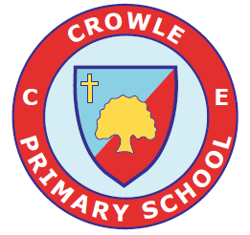

Crowle CE Primary School
Sex and Relationship Education (SRE) Policy

Date: September 2025 Review: September 2027

Our vision
At Crowle CE Primary School we aim to educate the whole child and to ensure children are consistently “Caring. Confident. Committed”

SRE is lifelong learning about physical, moral and emotional development. It is about the understanding of the importance of loving and caring relationships. Research demonstrates that good, comprehensive SRE does not make young people more likely to become sexually active at a younger age and in fact knowledge can help prevent this as well as helping to identify child protection issues in young children.

Policy Aims
The aim of SRE is to provide children with age appropriate information, explore attitudes and values, and develop skills in order to help them to make positive decisions about their health related behaviour. The SRE policy has the following aims:

- To provide the knowledge and information to which all pupils are entitled
- To raise pupils’ self esteem and confidence, especially in their relationships with others
- To help pupils to develop skills and to make the most of their abilities
- To develop pupils’ understanding of the importance of a healthier, safer lifestyle
- To help pupils learn to respect and care for their bodies
- To help pupils, parents and carers learn how to gain access to information and support

Values Framework

All those who teach aspects of SRE within school, including visitors, are expected to be guided by the following values framework which represents the values held in common by the whole school community. The teaching of SRE will encourage pupils to:
- Value and respect themselves
- Value and respect others
- Value and respect differences in people’s religion, culture, sexual orientation, physical and mental ability and social background

The personal beliefs and attitudes of teachers will not influence the teaching of SRE in this school.

Learning Outcomes for SRE within the School
By the end of Key Stage 1, pupils will have had opportunities to gain knowledge and skills necessary to build and maintain healthy relationships. They will have considered the effect of their behaviour on other people and identify and respect differences between people. They will also have discussed different ways in which family and friends care for one another. They will be able to explain ways of keeping clean and they will be able to name the main parts of the human body. They will also be able to explain that people grow from young to old.

By the end of the 4 years in Key Stage 2, pupils will have had the opportunity to express their views and respect those of others. They will have practiced skills in making judgements and decisions, and will be able to list some ways of resisting negative peer pressure around issues affecting their health and wellbeing. They will also have considered different types of relationship (for example, marriage or friendships), and discussed ways in which people can maintain good relationships (for example, listening, supporting, caring).

The following learning outcomes are taken from SCARF PSHE scheme:

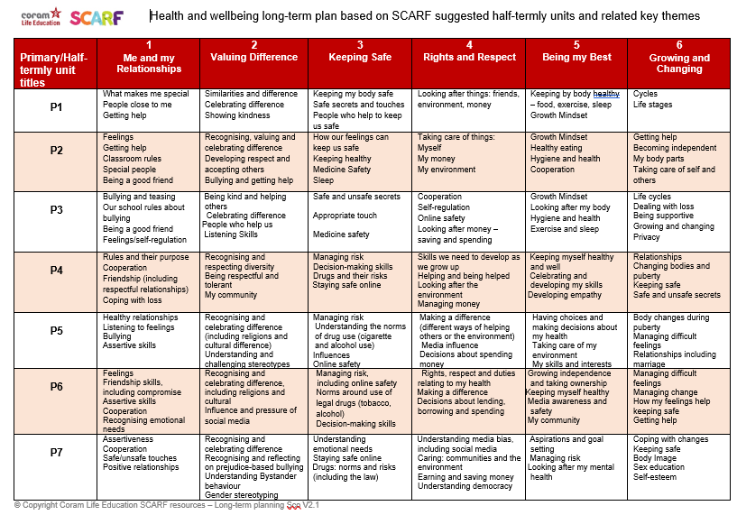

The Organisation of SRE
SRE is taught within the PSHE programme at Key Stages 1 and 2. Biological aspects of SRE are taught within the science curriculum and some moral aspects are taught within RE.

A range of teaching methods which involve pupils’ full participation are used to teach SRE. These include use of small group work, discussion, case studies, drama and role-play. SRE is usually delivered in mixed gender groups. However, there may be occasions when single gender groups are more appropriate and relevant. The programme content has been agreed in consultation with governors, parents/carers and teaching staff. This sex education content is more relevant to middle schools.

Use of visitors
‘Visitors should complement but never substitute or replace planned provision. It is the PSHE co-ordinator’s and teacher’s responsibility to plan the curriculum and lessons.’
Sex and Relationship Guidance DfEE 0116/2000 P 29 6.11

Visitors to school, such as parents/carers, health professionals and members of voluntary organisations, may be invited to plan and contribute to SRE lessons. They will be given a copy of this policy and will be expected to work within the values framework described within. The PSHE co-ordinators will ensure that the visitors’ contributions to lessons are in line with the learning outcomes of the school’s SRE programme. A teacher will be present during the lesson.

Terminology
OFSTED guidance recommends that it is important for children to learn the language associated with body parts so that children are able to talk to health professionals. Therefore, teachers will use the anatomically correct language for body parts, while acknowledging common terms used by some people. Correct language for body parts will be gradually introduced from Year 1.

Dealing with Difficult Questions
Ground rules are essential to provide an agreed structure to answering sensitive or difficult questions.

Teachers will endeavour to answer questions as honestly as possible, but if faced with a question they do not feel comfortable answering within the classroom, provision would be made to meet the individual child’s needs. This may involve referring the child back to their parent/carer, school health advisor/school nurse or young person’s health drop-in service for an answer. At Crowle CE, questions relating to specific sex education issues will be referred back to families.

Children with Special Needs
Teaching and resources will be differentiated as appropriate to address the needs of these children in order for them to have full access to the content of SRE.

Withdrawal of Students from SRE and Complaints Procedure
The school will include agreed information on SRE in the school prospectus and full details are available on request. The school will inform parents/carers when aspects of the SRE programme are taught.

Parents are informed of their legal right to withdraw their child from SRE. Any parent wishing to withdraw their child is encouraged to make an appointment with the head teacher to discuss the matter. Students cannot be withdrawn from any part of SRE which falls within the statutory National Curriculum Science orders.

Any complaints about the content or delivery of SRE should be addressed to the head teacher.

Equal Opportunities
All pupils are entitled to receive SRE regardless of ability, gender, race, religious belief or grouping. Through SRE we seek to develop a positive view of female and male sexuality. It is our intention that all children have the opportunity to experience a programme of SRE at a level which is appropriate for their age and physical development, with differentiated provision if required.

Objective discussion about the diversity of personal, social and sexual preference in relationships will take place in SRE and prejudiced views will be challenged in order to encourage tolerance. Any bullying around sexual behaviour or perceived sexual orientation arising from this prejudice will be dealt with as a serious matter. This is particularly relevant to Middle and High schools. These issues are not part of the taught SRE curriculum at Crowle CE First School.

Safeguarding/Confidentiality
Teachers need to be aware that effective SRE, which brings an understanding of what is and is not acceptable in a relationship, may lead to disclosure of a child protection issue. Under common law, young people are entitled to the same duty of confidence as adults. Personal information about them should not be shared without their permission except for the purposes of child protection. There may be rare occasions when a child under the age of thirteen who is sexually active directly approaches a teacher. This should be viewed as a child protection issue and procedures should be followed as outlined in Worcestershire’s Safeguarding Sexually Active Young People guidance www.worcestershiresafeguarding.org.uk

The staff member will inform the designated child protection staff member in line with the LA procedures for child protection. A member of staff cannot promise confidentiality if concerns exist.

Procedure for Supporting Those Infected with HIV or Hepatitis B or C
Staff should not expect to be informed of a pupil’s or colleague’s HIV or Hepatitis status. A member of staff, who is told of a pupil’s blood-borne viral status, should inform the head teacher and no one else. She/he will tell the pupil that this is what they are doing. No pupil or member of staff will be discriminated against as a result of such a disclosure.

First aid and control of infection practice should always follow current county guidelines; this will protect all school members from infection with blood-borne viruses.

Links with Other Policies
- PSHE & Citizenship
- Equal Opportunities
- Child Protection
- Confidentiality
- Behaviour
- Anti-Bullying

