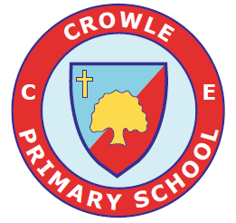

CROWLE CE PRIMARY SCHOOL

Handwriting Policy

Created on | September 2026
Frequency | Annually
Date of next review | September 2028
Available on website

Agreed by …………………………………. …………………………………………
(Headteacher) (Chair of Governors)

Date Agreed ………………………............

Introduction
The importance of handwriting should not be under-estimated. Good handwriting is an essential skill and must be actively taught by demonstration, explanation and practice across the whole school. A good standard of neat handwriting is a life skill, which enhances the presentation of work across different areas of the curriculum.

We believe that handwriting is a developmental process with its own distinctive stages of progression from letter formation through to letter joins while practising speed and fluency. Being taught letter formation in the correct families during the early foundation years of a child’s education will ensure a lasting and fluent handwriting habit. It is of utmost priority that the correct letter formation, letter direction and spacing are all embedded and used with skill before introducing joined up handwriting.

This handwriting policy is intended to enable all children in the school to develop a flexible, fluent and legible handwriting style, which will enable the children to write with confidence and creativity. It is vital that children are able to write with ease, speed and legibility.

Handwriting should become an automatic process, which frees pupils to focus on the content of their writing. In order for this to occur, it is important that all adults model the correct formation at all times, when marking, teaching and for display.

The success of this handwriting policy depends on the correct application of the policy throughout the whole school. Our responsibility as teachers is to ensure that high standards are achieved and maintained by following the whole school handwriting policy.

Handwriting Scheme

The school will take a whole school approach. Pupils will be taught the agreed style using Morrells Handwriting programme across the whole school. The Morrells Handwriting scheme follows the requirements of the current English National Curriculum.

Morrells Handwriting uses the Sassoon font. All classes will have the appropriate font (before or after joining) displayed in their classroom. It is cursive, but not fully cursive. This means it:

- Does not start on the line with the lead in but the letters do have the exit flicks.
- Capital letters stand alone and are not joined to the next letter.
- Does not loop the f, g or y
- Teaches the ‘k’ with a loop
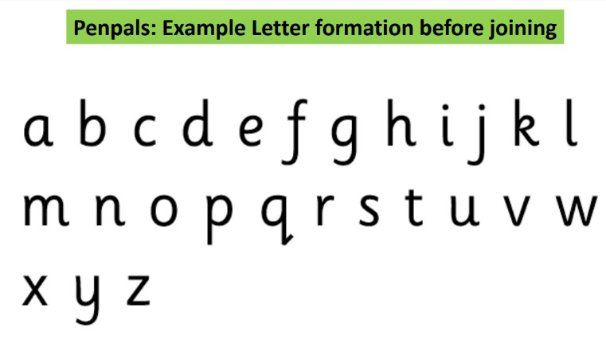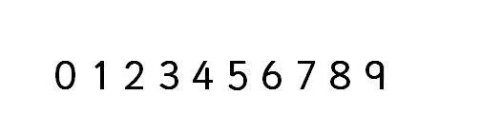
Cursive script
Printed script
Number formation
Aims
- To ensure consistent teaching through a whole school policy.
- To improve handwriting and achieve a higher standard in presentation skills in all subjects throughout the school.
- To teach handwriting in everyday lessons through every piece of writing throughout the whole school.
- To teach and reinforce correct number formation.
- To encourage pupils to take pride in their work and to instill a positive attitude towards handwriting.
- To make pupils aware that different degrees of neatness may be appropriate for different tasks.
- To demonstrate there is a balance between speed and legibility.
- To provide equal opportunities for all pupils, including left and right-handers and pupils with Special Educational Needs.

Provision
Handwriting and expected standards of presentation should be taught as a whole class activity. Intensive teaching is recommended at the start of each school year to clarify expectations, with further reinforcement in lessons.

Each handwriting session will include warm up activities to help gross and fine motor skills. Children should also be allowed to practise a particular set of letters, simply concentrating on developing accuracy, fluency and speed without the distraction of composing text. As for all motor skills, long practice sessions spaced apart are much less productive than short and frequent sessions.

Recommended timings
- Reception – The development of gross and fine motor skills are continuous and ongoing everyday. Children are taught correct formation of all lower case letters through phonics and the Morrells Handwriting scheme.
- Year 1 – 3 x 15 minute sessions per week
- Year 2 – 3 x 15 minute sessions per week
- Year 3 – 2 x 15 minute sessions per week
- Year 4 – 2 x 15 minute sessions per week
- Year 5 – 2 x 15 minute sessions per week
- Year 6 – 2 x 15 minute sessions per week

Initially, there may need to be additional handwriting practice outside of the normal Literacy lesson, as part of other curriculum subjects, as well as independent handwriting practice, for those children who are struggling with the fine motor skills required for handwriting, or if they are reversing their letters. For these children, a bespoke handwriting intervention will occur focusing on letters specific to their area of need, as identified through assessment from the class teacher.

Handwriting lessons will be at a speed that the writer feels comfortable with in order to complete each exercise/page precisely and correctly. If tiredness becomes an issue during an exercise, then we will allow a break or rest and return later to continue the task, (where the last work ended) or start a new exercise if an exercise was successfully completed.

Linking handwriting with spelling is one of the most powerful ways of developing the visual memory. Handwriting and spelling can be taught at the same time, one reinforcing the other.

Inclusion
Handwriting in all subject areas, exercises and work will be regularly monitored. The vast majority of pupils will be able to write legibly and fluently. However, some pupils may need more support.

Children who find handwriting difficult will be targeted for daily handwriting intervention and activities to develop gross motor skills and fine motor skills, along with plenty of pre-writing activities to loosen up the wrist and upper arm. Slanted writing boards, rubber pencil grips (grotto grips) and gross and fine motor skills programmes (Smart Moves) may be used to help children who find handwriting difficult.

Pupils should be taught handwriting precisely, in a clearly sequenced progression,
starting from Reception, to support their gradual acquisition of skills. This is achieved at Crowle CE Primary School through the six stages below:

- Readiness for writing, gross and fine motor skills leading to letter formation. (Pre-school and Reception)
- Learning and embedding letter formation. (Year 1 and Year 2)
- Learning and beginning to join. (Year 3)
- Securing joins. (Year 4)
- Practising presentation skills, speed and fluency using joined-up handwriting. (Year 5)
- Embedding presentation skills, legibility and fluency using joined-up handwriting. (Year 6 and Year 7)

In order to achieve this, children will be taught:
- To develop fine motor control.
- The importance of correct posture, sitting position and paper position whether right or left-handed.
- To use a pen/pencil and to hold it effectively.
- To write from left to right and top to bottom on a page.
- To start and finish letters correctly.
- To form letters of consistent size and shape.
- The language of writing and how to use the correct terminology, (e.g. ascenders).
- To put regular spaces between words.
- How to form upper and lower case letters.
- How to write legibly in both joined and printed style.
- To use different styles of writing for different purposes.
- The importance of neat and clear presentation in order to communicate meaning effectively.
- To develop greater control and fluency as they become increasingly confident.

EYFS
Reception
To enable children to acquire a legible, fluent and fast handwriting style, they need to develop good gross and fine motor control skills and recognition of letter shapes and patterns from an early stage.

Children will take part in a multi-sensory approach through activities to develop their fine and gross motor-skills and to recognise patterns. This will help prepare children for handwriting, consolidate their motor control and introduce letter shapes. Exploring letter shapes and letter formation using their index finger in sand; sky writing with both hands; making patterns on each other’s backs and using large equipment to make marks e.g. big chalks, Jumbo pencils and crayons, large paint brushes and finger paints will help pupils feel the movement in the hand. They will be given a range of materials to practise handwriting opportunities and to develop their handwriting to their full potential at that age.

Children should begin to learn how to correctly hold a pencil, then how to use a pencil to form recognisable letters. To aid movement, close attention will be given to pencil grip; correct posture and sitting position; the positioning of the paper and the organisation of the writing space.

A wide range of activities will help to develop hand and finger strength which leads on to developing a good pencil grip. Children will be taught to hold the pencil between the thumb and forefinger with the pencil resting on the third finger – the dynamic tripod grip.
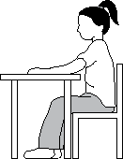
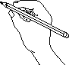
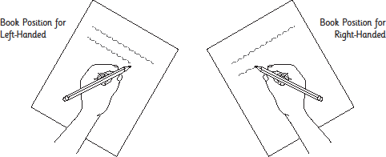
Copyright: Morrells Handwriting

At this stage the correct formation of letters is important. Children who have been allowed to invent their own ways of forming letters will find it harder to change. The longer they are allowed to persist, and unless these habits are ‘unlearned’, it will be very difficult for them to acquire a fluent, joined hand later.

To encourage the correct letter formation, the children will be taught letter formation in the correct families as per the requirements of the current English National Curriculum and the Writing Framework. We will be using the Morrells Handwriting scheme, which shows the correct starting point and the correct letter direction with the Morrells unique ‘Bounce Technique’. Learning letter formation and the natural letter shape in this way, at this early stage allows for an automatic movement and has a profound influence on later fluency and legibility, especially at secondary school.

Children will focus on the correct letter movement rather than neatness at this early stage.

Teachers will be vigilant to ensure that bad habits do not become ingrained and that the specific needs of left-handed pupils and those with Special Educational Needs are met. Children will receive instant feedback when errors in pencil grip, sitting position, or letter formation are seen.

Repetition entrenches the correct letter formation and letter direction, delivering a lifelong, good handwriting habit.

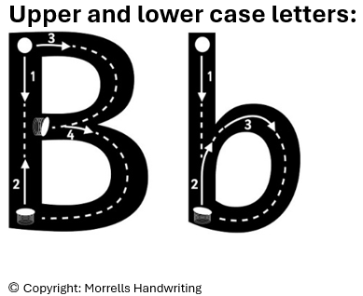
The letter formation families are:
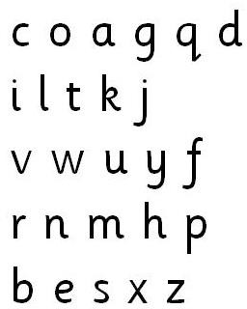

Upper and lower case letters will be taught together in the correct families. Children will be encouraged to write from the left hand edge of the page, or margin. It is expected that most children will be forming each letter correctly by the end of Reception.

Key Stage 1
Building on the work in the foundation stage, pupils at Key Stage 1 will continue to develop a legible style using Morrells Handwriting workbooks. Handwriting lessons will be frequent, ensuring the correct letter formation is used. Children will continue to develop fine and gross motor skills with a range of multi-sensory activities. Teachers and support staff will continue to guide and correct children on using a comfortable and efficient pencil grip and writing pressure. During handwriting sessions children will have the opportunity to practise letter formation to encourage good formation and reinforce previous learning. Emphasis will be on neatness and correct letter formation rather than quantity of work.

Linking handwriting and spelling are also important at this stage. The regular practise of letter patterns and the copying of high frequency words will help develop good visual and writing habits. By copying and tracing whole words and linking their handwriting to patterns learnt, the children will develop a good motor memory, which will aid independent writing and spelling.

Teachers will be vigilant to ensure that bad habits do not become ingrained and that the specific needs of left-handed pupils and those with Special Educational Needs are met. Children will receive instant feedback when errors in pencil grip; writing pressure; sitting position or letter formation are seen.

Children need to be made aware of:
• Where the letter starts and finishes.
• Where the individual letter stands with regard to the baseline.
• Ascenders and descenders.
• Spacing and finger space between words.
• Consistent writing size.
• Capital letters and their appropriate use.

By the end of Year 1, children will be able to write most letters using a comfortable and efficient pencil grip. Letters are correctly formed and orientated and children put spaces between words.

By the end of Year 2, most children will be able to print legibly using upper and lower case letters appropriately within words, with ascenders and descenders clearly distinguished, and observing correct spacing within and between words.

Pupils should be able to:
- Sit correctly at a table, holding a pencil comfortably and correctly.
- Form lower-case letters of the correct size relative to one another using the correct direction confidently, starting and finishing in the right place.
- Form capital letters and digits of the correct size, orientation and relationship to one another and to lower case letters.
- Use spacing between words that reflects the size of the letters.
- Produce writing which sits on the line most of the time.
- Understand which letters belong to which handwriting ‘families’ (i.e. letters that are formed in similar ways) and to practise these frequently.

If deemed appropriate after class teacher assessment, some children in Year 2 will be taught the diagonal and horizontal strokes needed to join letters in their writing. They will begin learning the diagonal and horizontal strokes, including the three joining strokes needed to join letters together using the Morrells Handwriting workbooks. The workbooks will also teach which letters, when adjacent to one another, are best left unjoined (the break letters).

Key Stage 2
During this stage the children continue to have regular handwriting practice. Children in lower Key Stage 2 will build on the work done in Key Stage 1 to help embed letter formation. In Year 3, once letter formation is secured, children will begin learning the diagonal and horizontal strokes. This includes the three joining strokes needed to join letters together using the Morrells Handwriting workbooks. The workbooks will also teach which letters, when adjacent to one another, are best left unjoined (the break letters).

They will begin to increase the legibility, consistency and quality of their handwriting (for example, by ensuring that the downstrokes of letters are parallel and equidistant; that lines of writing are spaced sufficiently so that the ascenders and descenders of letters do not touch).

Handwriting will continue to be taught in upper Key Stage 2 using the Morrells Handwriting workbooks, with the aim of increasing the fluency with which pupils are able to write down what they want to say. This, in turn, will support their composition and spelling. They will be using joined-up handwriting once they are confident at printing. The focus for handwriting will be to develop an individual style based on the principles of good handwriting taught in previous years.

Teaching and learning will focus on:
- Embedding letter formation, consistency in size, proportion and spacing of each letter.
- Sitting correctly on a chair at a table, holding a pencil comfortably and correctly.
- Writing with a joined style as soon as they can form letters securely.
- Ensuring that capital letters do not join to lower case letters.
- Developing a legible, joined handwriting style.
- Using joined-up handwriting the majority of the time.
- Maintaining legibility while writing fluently and with increasing speed.
- Neat and legible handwriting for presentation purposes.

We aim for them to develop a clear, fluent style and by the end of Year 6, pupils should be able to adapt their handwriting for different purposes, such as:

- A neat, legible hand for finished, presented work.
- A faster script for note making.
- An ability to print for labelling diagrams, or for algebra.
- Capital letters for filling in a form.

By the end of Year 6, most of the children will have developed a clear, consistent joined handwriting style, enabling them to write neatly and legibly in pen.

Teachers will be vigilant to ensure that bad habits do not become ingrained and that the specific needs of left-handed pupils and those with Special Educational Needs are met. Children will receive instant feedback when errors in pencil grip; writing pressure; sitting position or letter formation are seen.

Resources
The Handwriting Lead, English Lead and Headteacher will endeavour to support teachers in providing a range of high-quality resources, which will enable high quality teaching and learning to take place.

In Early Years, all pupils should have access to:
- A range of writing materials including chalks, crayons, paints, paper, notebooks.
- Grotto pencil grips for all children initially, then chunky pencils if deemed appropriate by the teacher.
- A range of other multi-sensory resources for teaching and reinforcing fine motor skills.
- The correct letter formation and the correct order to teach using the correct families as per the requirements of the current English National Curriculum and Writing Framework.
- Morrells Letter Formation Workbook 1.

At Key Stage 1 all pupils should have access to:
- Morrells Handwriting Letter Formation Workbooks 1 and 2.
- Morrells Handwriting wide lined shaded books.
- Sharp pencils.
- A range of other multi-sensory resources for reinforcing gross and fine motor skills.
- Grotto pencil grips and thicker pencils, as deemed appropriate by the teacher.
- Workbooks with wide spaced tramlines to support correct letter formation in English – see Appendix 3 for line requirements per year group.

At Key Stage 2 all pupils should have access to:
- Morrells Handwriting Workbooks appropriate to ability.
- Morrells Handwriting narrow lined shaded books.
- Sharp pencils.
- Handwriting pens, only when granted a pen licence in Year 5 after assessment from the class teacher.
- A range of other multi-sensory resources for reinforcing gross and fine motor skills, if deemed appropriate by the teacher.
- Grotto pencil grips and thicker pencils, as deemed appropriate by the teacher.
- Workbooks with narrower tramlines to support correct letter formation in different subjects

Assessment
In the Foundation Stage, assessment of letter formation will be ongoing and any incorrect letter formation will be addressed immediately and worked on in class, with support from home if possible.

In Key Stage 1 and 2, overall assessment of handwriting will be on-going through the marking of books and teacher observations where constructive feedback will be given. Scrutiny of handwriting will take place throughout the year by the Handwriting Lead and English Lead.

The Role of Parents/Carers
The school recognises the importance of keeping parents informed of our policy and procedures regarding the teaching of handwriting. We value the support of parents in encouraging and assisting their children with handwriting development. Therefore, parents/carers will be made aware of our agreed handwriting style and encouraged to practise this with their children at home. Parents/carers will be informed of the school’s approach to handwriting and they will be given guidance on the correct letter formation prior to their children starting at the school and as part of meetings for parents as children move up the school.

At times, homework activities will be also used to promote and practise handwriting styles.

The Role of the Teacher:
- To follow the school policy to help each child develop legible and fluent handwriting.
- To use all opportunities for writing as handwriting practice, regardless of subject.
- To observe pupils, monitor progress and determine targets for development.
- To use and model the correct letter formation and joined up handwriting.
- To correct poor letter formation and joined up handwriting.
- To ensure correct posture with children sitting comfortably and upright, with both arms on the table and feet flat on the floor.
- To teach the correct grip and writing pressure.
- To help improve muscle strength for handwriting through exercise.
- To make provision for left-handed children to develop free flowing writing.
- To ensure correct formation at all times through close monitoring of individuals.
- To ensure each child has a suitable implement before they begin and that pencils are adequately sharpened and pens are suitable for fluent writing.

New members of staff
New members of staff require a comprehensive period of induction to the teaching of handwriting, consisting of:

- Observing colleagues teach handwriting lessons, followed by paired discussion on teaching strategies modelled and how the lesson was structured.
- Team teaching with the Handwriting Lead.
- Meeting with SLT members, focusing on the principles behind the whole school ethos of good presentation of work.
- The new member of staff being provided with the Excellence In Handwriting booklet and all teaching materials, with clear explanation of how to use them.

