Diocese of Worcester Multi Academy Trust
Schools’ SEND Information Report
Crowle CE Primary School
September 2026
Introduction
This SEND information report is part of the Worcestershire local offer for learners with special educational needs and/or disability (SEND). This local offer can be found at the following site:

SEND Local Offer | Worcestershire County Council
All governing bodies of maintained schools and maintained nursery schools and the proprietors of academy schools have a legal duty to publish information on their website about the implementation of the governing body’s or proprietor’s policy for pupils with SEND. The information published must be updated at least annually. The required information is set out in the SEND Code of Practice 0 -25 Years 2015
SEND Statistics for school:

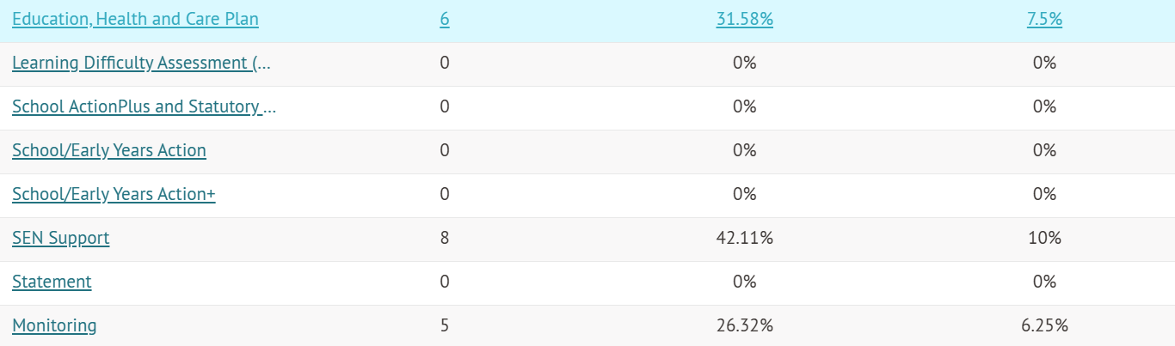

National SEND Statistics:

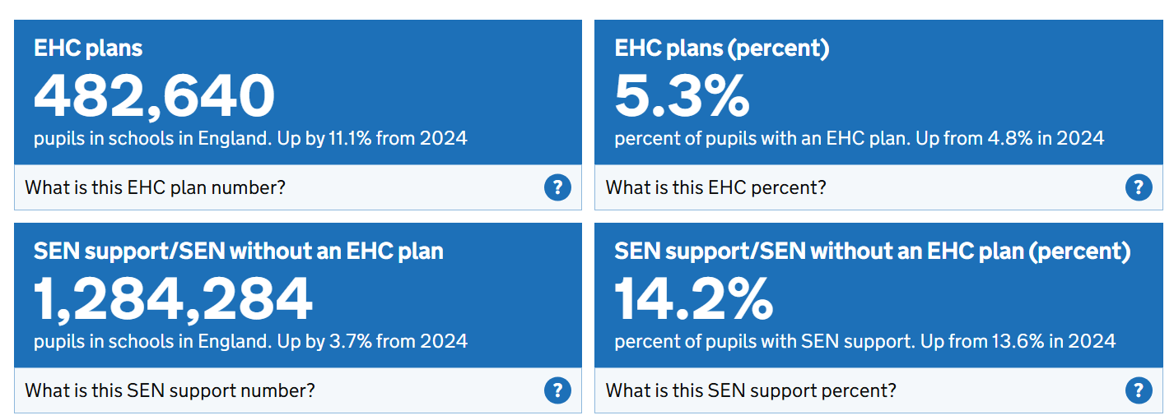

1 | The type of SEND  provision made | The DoWMAT consists of 15 mainstream Primary/First and Middle schools catering for children from the age of 2 to 12. It welcomes children with and without special needs and supports children with a range of SEND. These may fit into one or more of the following areas:  Broad Areas of Need:  - Communication and Interaction  - Autistic Spectrum Disorder (ASD) including Asperger’s Syndrome  - Speech Language and Communication Needs (SLCN)  - Cognition and Learning  - Moderate Learning Difficulty (MLD)  - Severe Learning Difficulty (SLD) - where children are likely to need support in all areas of the curriculum and have associated difficulties with mobility and communication.  - Profound and multiple learning Difficulties (PMLD) - complex learning difficulties as well as physical disability or sensory impairment.  - Specific Learning Difficulty (SpLD) including dyslexia, dyscalculia and dyspraxia  - Social, Emotional and Mental Health Difficulties  - Attention Deficit Hyperactive Disorder (ADHD)  - Attachment Disorder (AD)  - Sensory and/ or Physical Need  - Physical Impairment (PD)  - Hearing Impairment (HI)  - Visual Impairment (VI)  - Multi-sensory Impairment (MSI) A combination of vision and hearing difficulties  DoWMAT Schools have high expectations for pupils with SEND and endeavors to ensure that they:  - Achieve their best  - Become confident individuals  - Make a successful transition through school and on to secondary provision.  Each school uses its best endeavors to meet the needs of all children with SEND in consultation with parents, the Local Authority and specialist agencies from  Health, Education and Social Care.

2 | How do we identify and assess children with SEND? | Identification & Assessment  SEND pupils may be identified through the teachers’ observations and assessment,  and school based criteria including:  - Evidence obtained by teacher observations/ judgements - when teachers identify an area where a pupil is making slow progress, they will target the pupil’s area of weakness with differentiated, high-quality teaching. If progress does not improve, the teacher will raise the issue with the SENCO by completing an internal SEN referral document which identifies which of the four broad areas of need they are concerned about. They must also evidence a cycle of Assess-Plan-Do-Review to exemplify why they feel a child may have an additional need. A teacher referral will then be assessed via our identification criteria to establish if the child does have a special educational need, factors such as poor attendance will be taken into account and will form apart of the assessment process.  - Performance against national expectations  - Pupil progress in relation to Early Years’ Foundation Stage curriculum expectations and national curriculum targets  - Standardised tests which are tests to compare children of the same age nationally or criterion referenced tests such as high frequency word checks or phonic knowledge checks.  - External agency reports and observations  - Records from previous schools  - Information from parents  - We also closely monitor progress in areas other than attainment including social development and evidence that a pupil may have a disability under the Equality Act (2010).
3 | How do we safeguard children with SEND? | We aim to ensure that all children are protected from harm. Children identified as having special educational needs are more vulnerable than children who have not been identified as they may find it more difficult to communicate with trusted adults.  We ensure that children with SEND are safeguarded by following the safeguarding policy and through ensuring that staff receive specific training on how to identify possible signs of abuse for these children and that regular refreshers are planned in.  Relevant policies  - SEN Policy Safeguarding Policy
4 | What is our policy for making provision for all pupils with SEND? | See DoWMAT SEND policy:  Following identification and assessment we adopt a graduated response to meeting special educational needs and disabilities (SEND) in the following ways:  - Providing high quality teaching for all, differentiated for individual pupils.  - Involvement of the SENCO: If a child’s progress continues to be less than expected the class teacher will work closely with Special Educational Needs and Disabilities Coordinator (SENCO) to assess whether a child has a SEN or  disability.
- The school will then put evidence-based or school designed interventions into place, targeted to the needs of the individual, to secure better progress for the child.
- By providing specialist equipment: Where necessary a child may require specialist equipment to access and make progress in their learning.
- By involving specialist agencies: For higher levels of need DoWMAT schools will draw upon more specialised assessments from external agencies and professionals to support those identified with SEND.
- By applying for an EHCP: If a young person’s progress continues to demonstrate significant cause for concern despite interventions at school under the single category, a request may be made to the Local Authority for Statutory Assessment –Education, Health and Care Plan (EHCP).
Other policies of note:
Behaviour Policy Intimate Care Policy Anti-bullying Policy Health and Safety Policy
Marking and Feedback Policy
Policy for Supporting Pupils with Medical Conditions Complaints Policy
Accessibility Policy
a | How do we evaluate the effectiveness of provision for SEND pupils? | At DoWMAT the impact and quality of the support and interventions provided for individuals identified with SEN or Disability will be evaluated, along with the views of the pupil and their parents.  Support plans will be put in place after consultation with parents and staff. The attainment and progress of pupils on these plans will be evaluated at appropriate intervals. The class teacher in collaboration with the SENDCo will revise the support in light of the pupil’s progress and development. Any outcomes or changes to the support will be discussed with parents and pupil.
In addition, the SEND trustee, SENDCo and school leaders will regularly review the use of expertise and resources used to address SEND. The quality of the whole school provision will be evaluated as part of our approach to school improvement.

The SEND link governor is
The SEND governor will:
- Help to raise awareness of SEND issues at governing board meetings
- Monitor the quality and effectiveness of SEND provision within the school and update the governing board on this
- Work with the headteacher and SENCO to determine the strategic development of the SEND policy and provision in the school

b | What are the  arrangements  for  assessing and  reviewing progress? | SEND support at DoWMAT is based on four types of action assess, plan, do, review:  ASSESS  - SEND pupils may be identified in a range of ways as outlined in section 2  PLAN  - In liaison with the SENDCo, teachers will agree, in consultation with the parent and the pupil, the interventions and support to be put in place. Impact on progress, development or behaviour, along with a clear date for review will be expected.  DO  - The class teacher should remain responsible for working with the child on a daily basis.  - Where the interventions involve group or one-to-one teaching away from the main class teacher, the class teacher will still retain responsibility for the pupil, working closely with any teaching assistants or specialist staff involved, to plan and assess the impact of interventions.  - The SENDCo will support the class teacher in the further assessment of the child’s particular strengths and weaknesses, in problem solving and advising on the effective implementation of the support.  Plan  Once a child is identified with a Special Educational Need a support plan will be developed in consultation with the pupil and parents. This will include:  - No more than 4 short realistic and measurable targets related to the area of concern.  - Suggested strategies to be used by teacher, support staff, parents and pupil  - The teaching strategies to be used  - Identify the strengths of the child  - Details of intervention  - The provision to be put in place  - When the plan is to be reviewed  - Outcomes  REVIEW  - Support plans are to be reviewed termly, with input from the pupil, parent/carer, teachers, teaching assistants and outside agencies (if applicable).  - Pupils with an Education, Health and Care Plan have long and short term targets. Long term targets are reviewed annually at the annual review. Short term targets are devised and reviewed at least termly as described  above.
c | What is our approach to teaching pupils with  SEND? | At DoWMAT class teachers are responsible for delivering high quality teaching, differentiated for individual pupils. Teachers will plan to ensure a multi-sensory approach. Following identification and assessment we adopt a  graduated response to meeting special educational needs and disabilities (SEND). As much as possible support will occur in class, this may involve specialised resources or equipment and/or support from a Teaching Assistant (TA). Where SEND interventions involve group or one-to-one teaching away from the main class teacher, the class teacher will still retain responsibility for the pupil, working closely with any teaching assistants or specialist staff involved, to plan and assess the impact of interventions. Where possible, additional intervention work will ensure that children do not miss the same lessons each week. DoWMAT will ensure evidence- based/ school designed interventions are delivered by appropriately trained staff.  The SENDCo will support the class teacher in the further assessment of the child’s  particular strengths and weaknesses, in problem solving and advising on the effective implementation of the support.
d | How do we adapt the curriculum/ learning environment for SEND pupils? | All pupils at DoWMAT have access to a broad and balanced curriculum. Teachers will have high expectations for individuals with SEND.  Every teacher is required to adapt the curriculum to ensure access to learning for all children in their class. Our teachers will use various strategies to adapt access to the curriculum, acting on advice from external agencies, when necessary. These might include:  - Use of technology  - Use of practical resources/ specialised or modified resources  - Peer mentoring systems  - Positive behaviour rewards system  - Additional adult support  - Adaptation to visual stimuli including assessment materials  - Personalised activities
- Short, sharp interventions such as ‘Toe by Toe’ and ‘Jimbo Fun

’ Each learner identified as having SEND, is entitled to support that is ‘additional to or different from’ a normal differentiated curriculum. The type of support is dependent on the individual learning needs and is intended to enable access to
learning and overcome the barrier(s) to learning identified. The school is accessible to parents and children with disabilities. Within DoWMAT schools we have facilities to allow for movement from the ground floor to the lower ground floor, toilet, and care room facilities.
e | What additional support for learning is available to SEND pupils? | At DoWMAT where a pupil continues to make less than expected progress, despite evidence-based SEND support delivered by appropriately trained staff, we would involve specialists to give advice on effective support and interventions.  The involvement of specialists will always be agreed by parents and outcomes of visits will be recorded and shared with parents, teaching staff and other SEND support.  The local offer will set out clearly what is available from different services and how
it may be accessed. This may include:
- Speech and Language Service
- Educational Psychology Service
- Learning Support Service
- Autism Outreach/CCN Team
- Physical Impairment and Medical Inclusion Service
- Visual Impairment team
- Hearing Impairment team
- Perryfields PRU/ The Cherry Tree Centre
- Chadsgrove Specialist Support
- Child and Adolescent Mental Health Services
- Occupational Therapy Service
- Physiotherapy Service
- General Practitioners
f | What support for learning is available to SEND pupils  when the school closes unexpectedly? | Teachers will liaise with the SENDCo and other relevant colleagues to ensure all pupils remain fully supported for the period of remote education.  The SENCO will oversee additional support for pupils with SEND which will be unique to the individual’s needs, e.g. via weekly phone calls, individual sessions relating to their APDR and EHCP targets.  Reasonable adjustments will be made to ensure that all pupils have access to the resources needed for effective remote education.
 |  | Lesson plans will be adapted to ensure the curriculum remains fully accessible and inclusive during the period of remote education. Teachers will be reviewing the programs chosen for online learning for the accessibility features available, e.g. voice-to-text conversion to support pupils with SEND.
 |  | The school will consider whether one-to-one sessions are appropriate in some circumstances, e.g. to provide support for pupils with SEND. This will be decided and approved by the Headteacher.
As a result of school closures from March 2020 to March 2021, schools have made more use of assistive technology and online platforms to support learning. This has had a positive impact on provision which has
continued within the classroom and school setting beyond 8th March 2021.
g | How do we enable SEND pupils to engage in all activities of  the school? | Pupils identified as having SEND are supported to engage in all activities within school life. Reasonable adjustments and adaptations for participation are made  in order to ensure access to all curriculum and enrichment opportunities, including before and after school clubs.
h | What support available is for improving the emotional, mental and social development of SEND pupils? | We recognise that persistent disruptive or withdrawn behaviours do not necessarily mean that a child has SEND.  Appropriate assessments will be carried out to determine if causal factors are related to undiagnosed learning difficulties, communication and interaction difficulties or mental health issues and appropriate support will be put in place. This may include circle time activities in class, social skills evidence –based intervention groups or the involvement of specialist support. Specialist support may involve: Educational Psychology, Speech and Language, School Health Advisor or Child and Adolescent Mental Health Service.  If housing, family, or other domestic circumstances may be contributing to the presenting behaviour then a multi-agency approach may be appropriate through the Early Help process.  Appropriate support will be provided in distressing circumstances, for example, where bullying is suspected or there has been bereavement, as we are aware of the significant impact that this can have on the well-being of a pupil.  Policies of note:  - SEND Policy  - Behaviour Policy  - Anti-bullying Policy  - Bereavement Policy
5 | The SEND  coordinator’s name and contact details | School SENDCo – Clare Stockford  DoWMAT Trust SENDCo – Clare Stockford  Clare.stockford@dowmat.education
6 | Information on staff expertise their SEND training, and how specialist support will be secured | SEND training within the school happens in many ways. We take advantage of courses being delivered by external agencies in all aspects of SEND provision. We also commission external agencies to come into school to work with larger groups of staff. Throughout the year we provide training in house for both teaching and non-teaching members of staff. The focus of training is planned based upon the training needs of our staff as well as the needs of our pupils.  Our SENDCo has been awarded the National Diploma for Coordination of Special Educational Needs and many of our schools also have a Senior Mental Health Lead in school. Class teachers and support staff have received up to date training related to various areas of SEND.
7 | Information on equipment and facilities to support SEND pupils and how this will be secured. | Allocation of resources  - Resources are allocated to support children with identified needs.  - Each year we map our provision to show how we allocate human resources to each year group; this is reviewed regularly.  - Support may take the form of differentiated work in class, support from a Teaching Assistant (TA) in focused intervention in groups, or for individuals.  - Where necessary specialist equipment, books or other resources that may help the child are purchased.  - DoWMAT works closely with specialist professionals to ensure that accurate information is accessed regarding equipment and facilities to support SEND pupils.
8 | What arrangements are there for consulting parents of pupils with SEND, and involving them in their  education? | Early Concerns/Identification  - The progress made by all pupils is regularly monitored and reviewed. Initially, concerns registered by teachers or other agencies are addressed by appropriate differentiation within the classroom and a record is kept of strategies used.  - Where progress continues to be less than expected parents/carers will be invited in to school to begin the Assess, Plan, Do, Review process.  - There is an open-door policy. Parents can arrange to meet with their  child’s class teacher or Special Needs Coordinator to discuss any concerns  at a mutually convenient time.
9 | What arrangements are there for consulting pupils and involving them in their education? | - As discussed, where progress continues to be less than expected the SENDCo will invite parents/careers in to discuss the next steps in order to further assess the young person. Following this the SENDCo or class teacher will meet with the young person to complete their plan. This will include the child’s thoughts on their strengths and weaknesses and suggestions for targets to work towards. It will also consider support that they feel would be appropriate and helpful. A date will be set when this will be reviewed with the child.  - Depending on their age, pupils with an Education, Health and Care Plan are invited to submit their views in writing as part of their annual review  as well as to attend the review itself.
10 | Trustee arrangements for the treatment of parental/  pupil complaints concerning the  school’s  provision | Arrangements for considering complaints about SEND provision.  If a parent/carer has a complaint about SEND provision it should first be raised with the school. In the first instance concerns should be raised with the class teacher. If a satisfactory outcome is not achieved the SENDCo will become involved. In some instances, it may be necessary to consult the Head Teacher. In extreme cases the parent may be referred to the LA. A parent can also be directed towards the Special Educational Needs and Disability Information, Advice and Support Service (SENDIASS ).  See Complaints Policy.
11 | How does the Board of Trustees involve other bodies (health, social care LA  support | We work closely with the Local Authority and other providers to agree a variety of specialist services and have clear arrangements for making requests for specialist services.  We commission some specialist services directly, for example:  - Learning Support Service  - Educational Psychology Service.  We are also supported by health care professionals such as:
 | services and voluntary organisations) in meeting the needs of children  identifies with SEND? | - Physiotherapists  - School Nurse  - Child and Adolescent Mental Health Services (CAMHS) Or other services such as:  - Charity Organisations  - Social Workers  - Early Help Services  - Young Carers
12 | The contact details of support services for parents of SEND pupils | Worcestershire Local Authority –  SEN services - 01905 845579  North: 01905 845134  South: 01905 843134  SENDIASS- 01905 768153  Chadsgrove Specialist Support- 01527 871511  Perryfields PRU- 01905 427011  Newbridge PRU- 01905 763580
13 | The school’s transition arrangements for SEND pupils | Transition Arrangements  The following information and documentation is provided by the SENCo to the receiving school for pupils with Special Educational Needs:  - Assess, Plan, Do, Review Support Plans  - Education, Health and Care Plans  - Assessment details  - Reports  - Liaison with school staff of receiving school  For pupils with Educational, Health and Care Plans a transition review will take the place of the annual review in year 5. This review must give clear recommendations as to the type of provision the child will require in future years.  In some instances, specialist services involvement and guidance in transition may  be required, for example Autism Outreach.
14 | Link to the  authority’s  local offer | SEND Local Offer | Worcestershire County Council

